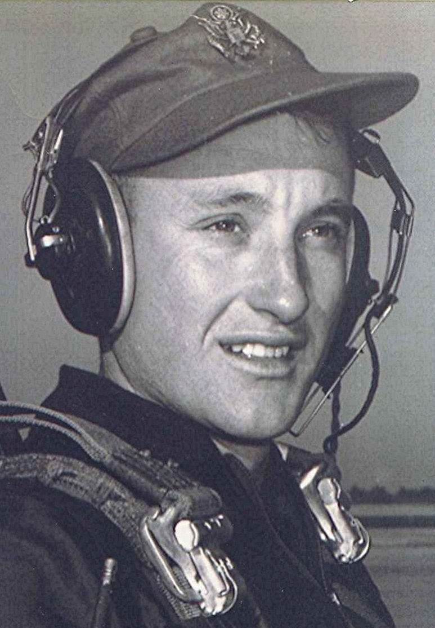
Clover Leafs & other difficulties
There was one maneuver, called the “Clover Leaf” that brought to bear all the skills that a student pilot possessed in order to complete it successfully. He could do everything else pretty well, but that one maneuver he never seemed to conquer. The day of his final check in the T-28, preparatory to advancing to the T-33, he hoped against hope that the acrobatic maneuver that the check pilot asked him to demonstrate would be anything but the dreaded Clover Leaf. Toward the end of the flight, it came time for a demonstration of acrobatic skills. The check pilot said, "Let's have a Clover Leaf." His jaw dropped and he thought, "Oh, No!" Then he said to himself, "The heck with it!"
He abandoned all caution and pushed the nose down to gain airspeed. When the speed built sufficiently, he pulled the stick straight back and watched the nose rise above the horizon until it was pointed straight up. It is at this point that the maneuver is most critical. While the airplane is perfectly vertical, the wings are rolled to a point that when the airplane continues over on its back and drops through the horizon, inverted, the nose falls through the horizon exactly ninety degrees from the direction the maneuver was started. The inverted airplane is then pulled through the bottom of the loop until it is again upright. At this time it should be heading two hundred seventy degrees from the starting direction. This is one lobe of a four-lobe maneuver. The same procedure is continued until all four lobes are completed and the airplane back on the original heading.
He threw all caution to the winds and blindly yanked and turned the airplane, sometimes losing his sense of where he was in the maneuver. He finally stumbled out of the fourth lobe, heading North, where he had started.
When they returned to the base, the check pilot debriefed the ride. He commended his student on a good flight and said, "You really have the Clover Leaf nailed! That was one of the best that I have ever seen!" Given enough bad luck, the student felt that some good had to come along sometime. For him, it happened that day. Of course, he didn't tell the check pilot that the majority of it was done with eyes closed.
They spent only a short amount of time in the T-28's. The majority of their time was consumed in learning to fly the jet trainer. The differences were bordering on the phenomenal, with fewer engine controls, far less noise and vibration and sequential actions compressed sometimes beyond their amateurish comprehension. The speeds at which things occurred required the development of habits that caused one to think two or three steps ahead. Otherwise, they wound up way behind the airplane. As someone has put it, "If the airplane had crashed on takeoff, I would not have been hurt, for I was still back on the runway!"
Formation flying in the sleek, swift planes was a real challenge. While flying formation in a propeller driven airplane, the propeller acts as an air brake, allowing the pilot to increase and decrease speed almost instantly, similar to using the brake and accelerator on an automobile. In the T-33 there was a slight lag after the application of power and when the throttle was decreased, the airplane continued to accelerate. There were speed brakes, but they induced a sudden deceleration along with a violent pitch-up of the nose, therefore they were used in emergencies or only after coordination with others in the flight. In spite of the difficulties of adjusting to the lead-lag aspects, it was an exhilarating thing to fly alongside another T-33, with wing tips only a few feet apart, close enough to read the decals below the canopy and the name on the pilot's helmet.

