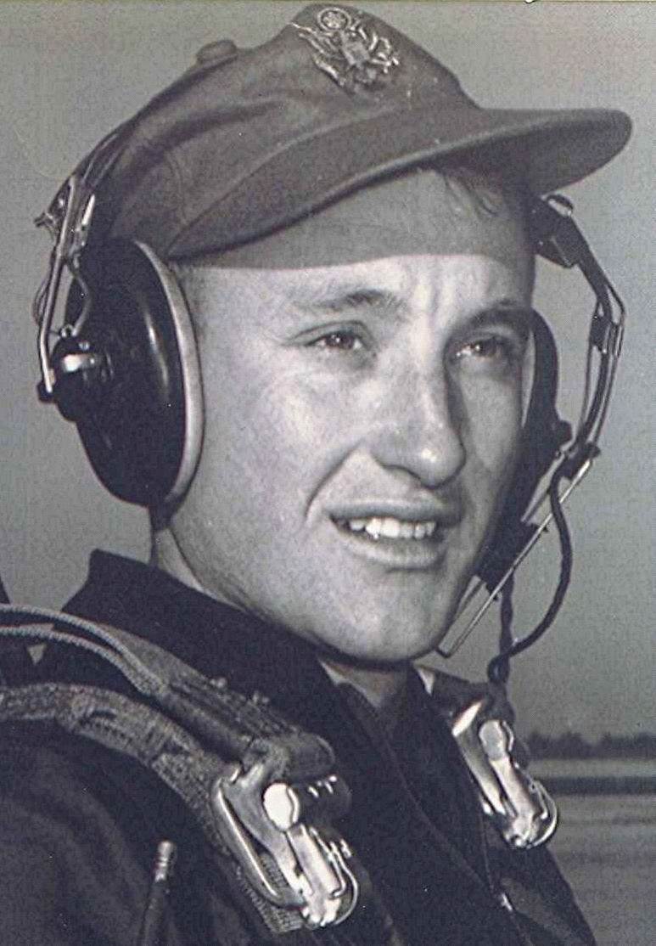
Byran, Texas; Summer of 1955
Bryan Air Force Base sat amidst the cotton fields, a few miles north of the twin towns of Bryan and College Station, Texas. Texas A. & M. College was close by. Its student body was all-male, presenting the aviation cadets with the prospect of a very tough competition for the attention of women of courting age or women of any age, for that matter, who might be unfortunate enough to live in the two small towns. It was late in the evening when he got off the bus in Bryan. He took a taxi to the college and got a room at the student union. It was the newest building on the campus which, at that time, had acres of open, undeveloped space scattered throughout. As he checked in at the student union, he saw Aggie cadets everywhere. He had the strange feeling that he was only adding to an over-supply of cadets, Air Force or otherwise.
Bryan Air Force Base
When he arrived at the Air Force base the next day, the place was crowded with the new arrivals from Primary Training. He saw a lot of the familiar faces from Marianna, as well as some whom he had not seen since preflight at Lackland; their paths again converging. The first shock was the reception they received from the upper class cadets. Shades of pre-flight; there were underclassmen standing at attention while being dressed-down by very militant upper classmen. As one upper class cadet informed them, "You are back in the military, best you recognize that!" They were stunned, they had hoped that such treatment was all behind them. Being in the upper echelons of the students at their Primary base had spoiled them. Here they were, once again, at the bottom of the pile. Bryan was very much a military base and they had military instructors, academic and flying. The reality of marching, drilling and observing all the strictures of military life soon became routine. The hazing and harassment began to taper off after a couple of weeks, allowing them to concentrate on flying and academics.
The contrast with Graham, with its new buildings and its resort-like setting, was quite vivid. Bryan had been a World War II training base and with only one or two exceptions, the buildings all dated from that time. The barracks had been hastily constructed of boards overlaid with tar-paper. Thy were laid out in a square, encompassing what was called the quadrangle. In the middle of the quadrangle a white wood building housed the latrines and showers. Each barracks building was partitioned off into small cubicles, each cubicle containing two iron cots. There were two small shelves attached to the wall. Beneath each shelf, an open coat rack. At the end of each bunk there was a wooden foot locker. The barracks floor was about eighteen inches above the ground. The four-inch pine flooring had cracks and knot holes, through which the ground beneath could be seen. There was no running water in the barracks. To reach the showers and the latrine they had to cross about seventy-five feet of open area. The secretaries in the nearby administration buildings later complained of the semi-nude and sometimes nude cadets who streaked to and from the barracks and the showers. Fortunately, their training was completed during the summer and early fall months; what the cadets did in winter to stay warm, he didn't have to worry about.
There were advantages in being stationed at a rather dilapidated base such as Bryan. Their clean-up prior to the Saturday morning barracks inspection consisted of sweeping the floor with a broom, then hosing it down with water from the fire extinguishers that hung on the walls. The place was so crude and rustic that any attempt to spit-shine would have been futile.
They had their own chow hall, right by the cadet area. Although it was government food, the mess sergeant in charge provided some great meals, they quite often had steaks, and there was a plentiful supply of watermelon, cantaloupe, and fresh fruit; they soon settled in, with the old buildings, gravel paths, and remote bath facilities seeming more home-like with each passing day.
In contrast with the aging buildings, the planes at Bryan were up-to-date. The T-28 Trainers, the ones in which they would begin their training, were new. These were to be an intermediate step between the slow propeller-driven T-6 and the much faster T-33 jet. These had a much larger engine than the T-6. The plane's performance, they were told, approached that of the World War II fighter, the P-51. The airplane was a pleasure to fly. The visibility provided by the bubble canopy was almost unlimited. However, there was a deficiency. The Air Force had purchased trainers with a seven-cylinder Wright engine. The engine had a split exhaust, with four stacks exiting on one side of the engine nacelle, and three on the opposite side. The sounds coming from the exhausts were similar to the old John Deere two-cylinder tractors. Because of the sound, the engine was dubbed "The Washing Machine." Additionally, the seven cylinder engine had several RPM restrictions, both in high and low ranges. To remain within the restricted speed ranges for any length of time was to risk damage from vibration. The Navy, meanwhile, had equipped their T-28's with a much larger Pratt & Whitney engine that drove a four-blade propeller, compared to the two-bladed ones on the Air Force trainers. The Navy trainer outperformed the Air Force plane by a wide margin.
In many ways, the training regimen at Bryan was a repetition of that at Graham, but there were differences. By now, they were becoming more seasoned and adapted to flying a radial engine airplane. The challenge was mainly that of learning the procedures involved in flying the T-28, which was much easier to fly than the previous airplane. It had a tricycle landing gear. The nose gear kept the plane level with the ground during taxi, takeoff and landing, rather than the nose being angled skyward, as was the case with the conventional-gear T-6. The T-28 landed mostly by pointing it at the runway and reducing the power. It practically did the rest by itself.
Their instructor pilots were young Air Force officers. A large percentage of them were Korean War veterans. The students practiced landings, acrobatics, and formation flying along with other prescribed maneuvers. Some of the Acrobatic maneuvers were complicated and hard to complete, even though they were flying an extremely responsive airplane.

