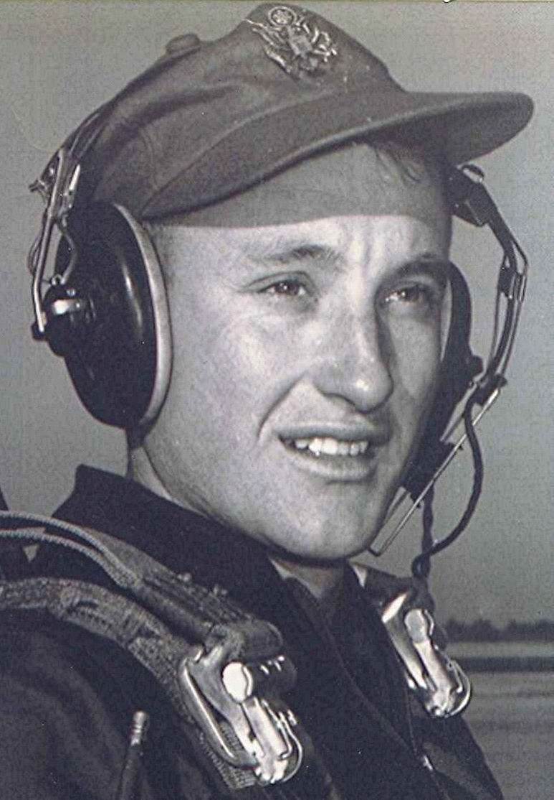
the end of primary Training
It was spring when they finished at Graham. The exuberance over graduation was dampened only slightly by the knowledge that this was only the second stage of a three stage process: Preflight, Primary and, still to come, Basic with its challenge, the jet trainers. Occasional letters from upper class members, who were already in Basic training, were encouraging. They had anxiously awaited the assignments to their next base. When these came through, he learned that his next station was Bryan Air Force Base near College Station, Texas.
There were a few days of leave between assignments. He arranged to ride as far as Memphis with an older cadet who had previously been in the Marines. The ex-Marine was one of the three or four cadets who had an automobile while they were in Florida. There were numerous restrictions on bringing an automobile and only a few bothered to go through all the paperwork involved in obtaining permission to keep a car while in training. Besides that, most of them couldn't afford one anyway. The ex-Marine's car was an old Dodge convertible. The day they left, the convertible's top was down, the sun shone brightly and the air was warm. It was a perfect way to say farewell to Graham Air Base.
They intended to get a quick tan while on their way home, mostly in hopes of impressing the young ladies back there. There had not had many opportunities for sun bathing during the previous months. Along the way some shed their shirts, their skin coloring similar to that of a tray of haddock at the fish market. At the end of the day, the results weren't quite as planned. Most had the appearance of boiled lobsters, from the combination of sun, heat, and wind blast. That night, he got off in Memphis and caught a bus for Bearden, Arkansas.

