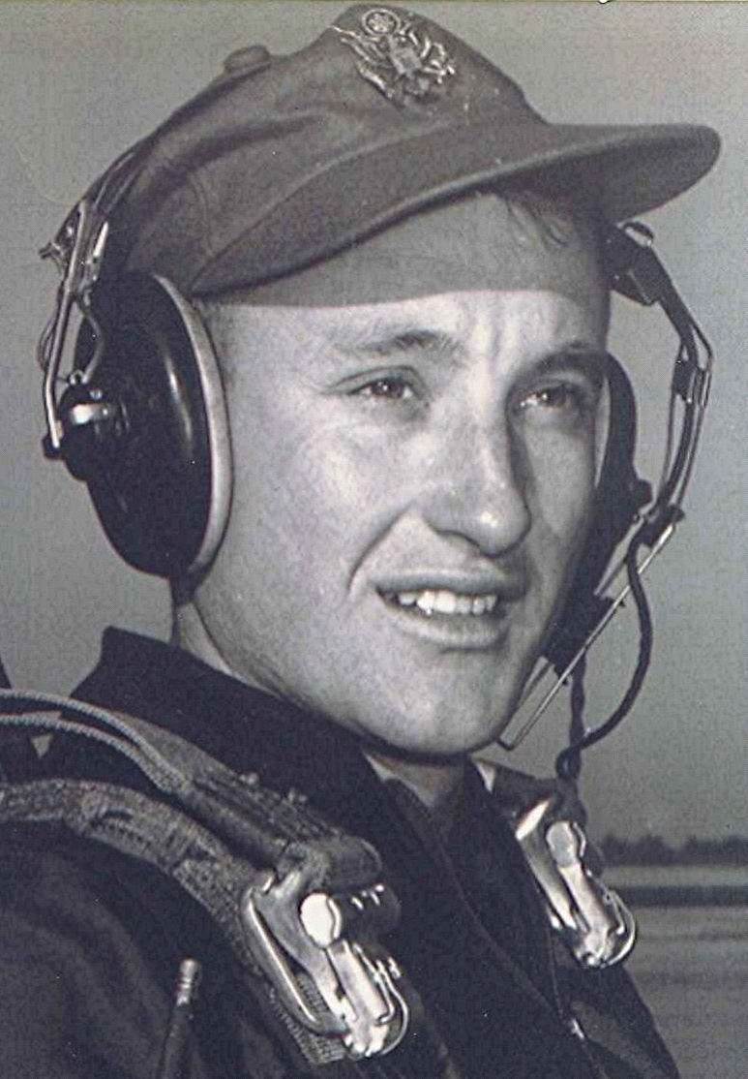
military life at Graham
The barracks at Graham were built like motel rooms, with a latrine between each two suites of rooms. Each room had four occupants. For the first time since entering the Air Force, they slept on beds instead of bunks, they each had a metal locker in which to keep clothing and equipment. Frequently, on Saturday morning, there was an "open locker" inspection. This meant that only certain items could be displayed in their lockers. Everything must be neat and clean in order to pass the white-glove inspections. Although military discipline was certainly not as severe as at Lackland, the training officers at Graham took inspections seriously and issued a lot of demerits.
The tour path, which was located between their barracks and the cadet club, was filled each weekend with cadets walking off demerits. There were two or three who had been cited with what was called a seventy-two gun salute—the number of demerits assessed for being absent on an unauthorized Open Post: being off base beyond curfew without a pass. This was a cadet version of AWOL. Needless to say, the recipients of a seventy-two gun salute spent every remaining week-end walking tours.
Most, if not all, of the cadets had more gear stored in their lockers than was allowed during inspections. Some means had to be devised to dispose of this excess during the open-locker inspections. Someone discovered that out in the woods behind the barracks there was a large ditch or ravine. Each Friday night, when everyone was frantically preparing for the impending inspection the following morning, there was a steady flow of cadets from the barracks to the ditch. There, all the golf clubs, excess equipment, clothing, etc, was stowed. One Saturday morning about midway in their training, the public address system, . which originated in the Tac Office across the street from the barracks, announced that the open-locker inspection was over. "And, by the way," the voice intoned, "those of you who had equipment hidden in the ditch may claim it at the Tac Office, along with the appropriate demerits!"
The Tac Officer was a mild-mannered captain named Adams. The cadets didn't see an awful lot of Captain Adams. As at Lackland, most of the drill, training, and discipline was administered by members of the cadet officer corps. Roll call out on the road was a morning ritual. During the winter it was still dark when they gathered on the road beside the barracks. The cadet officers had become lax and there was a lot of talking and horsing around during the formation, which lasted only about five minutes. Things became so informal that some cadets didn't bother to get dressed before they showed up for the formation. They arrived in the darkness, dressed only in their under shorts, shower clogs, and raincoat with hat. One morning, amidst all the talking and tittering, someone noticed an additional form in the ranks. This one had an Air Force officer's hat and captain's bars. It was Captain Adams who apparently had gotten wind of the proceedings and had come to check the situation. The tour path experienced a pronounced increase in occupants that week-end.

