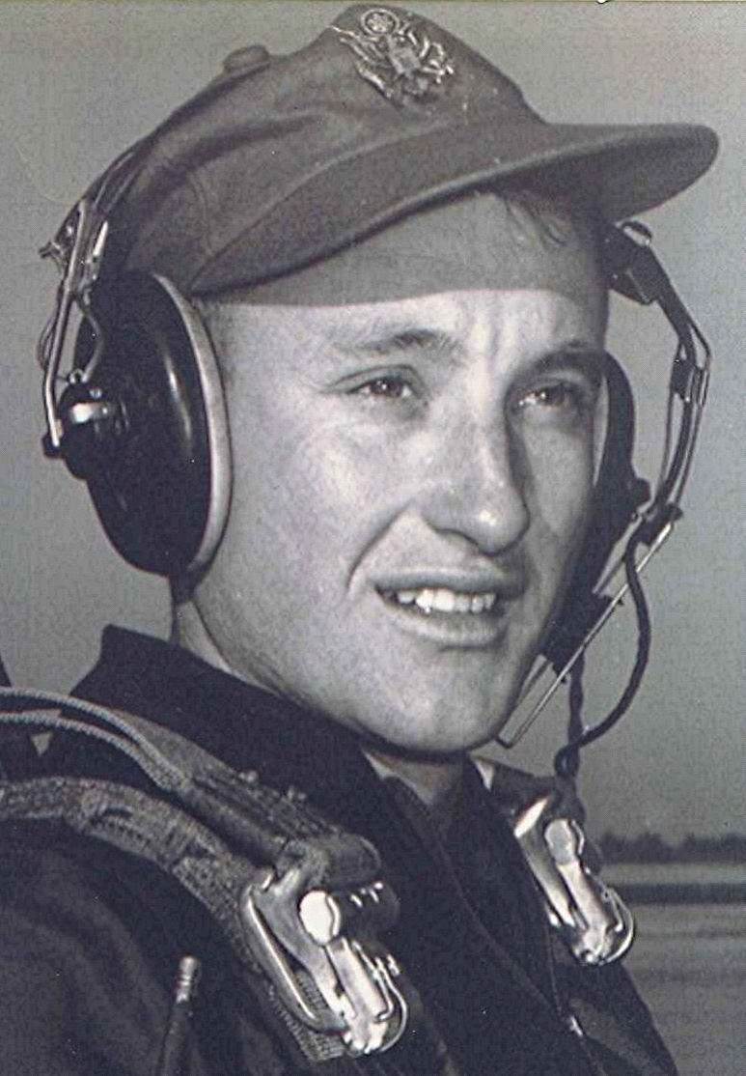
primary flight training
He rode a Greyhound bus from Little Rock, Arkansas, to Marianna, Florida. They went through Holly Springs, Mississippi. Most of the highways were two-lane and crooked. The bus stopped at practically every town of any size along the way. On the outskirts of Birmingham, everything was layered with a covering of red dust. The steel mills around Birmingham were in full operation back then and the whole area was dusty and dirty. They stopped at the bus station and off-loaded for a rest stop. After about thirty minutes they re-boarded the bus. When he got on, all the seats in front of the bus were full (This was in the deep south when segregation still existed). Thinking little of the matter, he proceeded to the back of the bus where he sat down amidst the blacks. He noticed one or two of them looking at him in a rather questioning manner. About that time the driver boarded. After placing his personal items around his seat in preparation far the departure he looked up at the mirror and studied his load of passengers. All of a sudden, his eyes opened wide when he saw the white cadet in uniform sitting at the very back of the bus. The driver got out of his seat and motioned him to come to the front. There he was informed, in no uncertain terms, that he must stand at the front of the bus until a front seat was available. The bus had traveled several miles down the road toward Montgomery before a seat was open.
The trip took the better part of two days. They arrived in the panhandle of Florida in the early morning hours, passing through Dothan, Alabama and Cottonwood, just across the Florida line. He was disappointed. It didn't look anything like he had envisioned. In his mind, Florida should have looked like the area around Miami, with white sand, palms and citrus orchards. Here, there were only large live-oak trees draped with Spanish moss; it looked essentially the same as south Alabama, with cotton fields and Bermuda grass pastures.
It was mid-morning when he got off the bus in Marianna, a sleepy little rural town. Someone at the bus station gave him directions to Graham Air Base, which was northeast of town some four or five miles. A local taxi ferried him out there. A long row of majestic live-oaks lined the avenue that led from the front gate. Beneath the moss laden trees, the new quarters were laid out in neat rows, somewhat like a cluster of one story motel buildings. The clean new buildings, the sandy soil, and Spanish moss hanging from the trees reminded him of a resort, rather than a military training base.
Most of the buildings in the cadet area were new: the cadet club; the academic building; the fire station. The dining hall was an older building, a left over remnant from World War II, as was the hospital. Graham was a civilian contract flying school, operated by a civilian organization, Graham Aviation, which had a contract to train pilots for the Air Force.
Other than the cadets, military representation on the base was very minimal. There were three or four non-rated Air Force officers who were responsible for their military training and some three or four Air Force pilots who administered the check flights. All the flight instruction and most of their academic training was by civilians who worked for Graham Aviation. There was a small contingent of medical people who were also in the Air Force.
Each civilian flight instructor was assigned three students, their flight schedule alternated weekly between morning and afternoon flights. The students who had morning flights were up before daylight and marched to the flight line, stopping on the way to eat breakfast. The academic classes started later in the morning, so those who had morning academics and flew in the afternoon had a good bit of time between reveille and class. He dreaded the morning flying sessions because of the early hours, especially on Mondays. Almost, if not all, the flight instructors were former World War II combat pilots. His was an ex-Navy pilot named Brandenburg, who was originally from Texas but lived in Panama City and drove home on week ends.
The flight line was about a mile or so from the cadet area. To get there they marched, (or straggled) along a sandy dirt road that passed in front of the dining hall which stood in an open field, about midway between the two areas.
At Lackland they had the standard GI food which was supplemented with extra milk, juice and fresh fruit. All that paled in comparison to the extraordinary fare at Graham. The civilian cooks were superb and the dining area was more like an upscale restaurant than a chow hall. A lot of people had difficulty keeping their weight down. Here, they were not undergoing the rigorous physical training as before, which only added to the problem. In his letters to home, he tried vainly to describe the great food that they enjoyed. The food and the new, comfortable living quarters helped elevate pride much more than being reminded that they were in the top three-percent.
At Graham, for the first time they encountered students from foreign nations. These cadets and officers were referred to as 'M-DAPS'. an acronym for Mutual Defense Assistance Pact—an agreement between the United States and several foreign countries under which foreign pilots trained in the United States. M-DAPS were easily distinguished by their uniforms, which were worn by their nation's air force. In most cases it was an almost instant dislike for the foreigners. The foreign cadets in their upper class had the authority to discipline the lower class for infractions of the rules. They (allegedly) could issue 'gigs' for those infractions. Some groups were worse about that than others.
The Dutch were especially obnoxious. Their uniforms were sloppy and often dirty. They seemed to delight in having authority over the Americans in their lower class. Unfortunately, the Dutch seemed to be the most prevalent of all the nationalities at Graham. The lower class soon learned that their threats were more imagined than real. There was one, in particular, who marched along with the lower class while repeating, "I will gif you gig." They chose to ignore him as he was a cadet sergeant, with little authority.
To their dismay they also learned that the foreign students were not required to abide by the Cadet Honor Code. Instances of theft and lying in which foreign cadets were involved were difficult to do anything about. In addition to the Dutch, there were other countries represented, such as Spain, Columbia, and Brazil. Some of these cadets maintained fairly good military standards. The Spanish wore clean uniforms and were quite friendly. During flight training, some of the cadets' class mates were officers from foreign air forces. The foreign officers were fairly sharp people.
When they reported each day to their briefing room at the flight line, the trainees were joined by the Air Force ROTC lieutenants who were also in flight training. There was a certain amount of animosity on the part of the cadets toward the student officers. These students, who were already commissioned and drawing officer pay, (and enjoying officer privileges) knew less about military customs and traditions than the cadets. At least, that is what the cadets believed; and there was a lot of evidence to support that. When the lieutenants' formation stood alongside those of the cadets during the occasional Saturday parades, the contrast was obvious. The cadets' tailored uniforms and crisp marching elements contrasted sharply with the lieutenants' wrinkled and baggy uniforms with insignia that was often askew. They exhibited an almost casual regard for military ceremony. The sum of all this was that the aviation cadets looked upon the ROTC officers as the "unwashed."
When a cadet formation marched past a group of the new lieutenants, it would often break out in the song:
“Some mothers have sons in the Army
Some mothers have sons on the sea
But take down your service flag mother,
Your son's in the ROTC.
RRRRR... 0, RRRRRR...0,
Your son's in the ROTC."
The disdain with which the cadets regarded the ROTC officers could have been influenced somewhat by their envy of the lieutenants' pay and status.
At Graham, the newcomers were surprised at the laxness in military discipline. Most of their upper class treated them as equals. At Lackland, where there were two classes, upper and lower. Here, there were four, each in a different stage of progress in the flying program. As one upper classman explained, "We're all here to learn to fly, and don't have time to worry with the hazing and stuff that went on at Lackland". Here there were many upper classmen whom he had not seen back at Lackland.
The academic training was in a new brick building directly across the road from the cadet club. In the classrooms there were mock-ups of aircraft instrument panels, hydraulic and electrical systems and flight surfaces. There was a Pratt & Whitney radial engine which powered the T-6 Trainer. A portion of the cylinders was cut away, providing a view of the actions of the pistons, valves and push rods and propeller as the engine rotated. Other classes, such as Meteorology, Instrument Flying , and Aircraft Systems were scheduled throughout the months at Graham. The initial challenge was to memorize the check lists to be used while flying the Piper Cub and the North American T-6.
It was in the late fall when they had their first flying lesson. There were eight or ten Piper Cub airplanes for the beginners. These operated from a sod strip located away from the main runway, which was used by the much faster and heavier T-6 trainers. The Piper Cub or PA-18, its military designation, had two seats and a few instruments with which to monitor airspeed, altitude, and engine speed. It had no radio. Communication between the airplanes and the mobile control tower was maintained through the use of red and green signal lights and flares, somewhat reminiscent of scenes from movies of World War II. While the students were accompanied by an instructor, the instructors maintained proper spacing in the traffic and landing pattern. This avoided confusion and lessened the chance of an accident. Afterward, when they flew solo, it was up to the students to maintain separation in the traffic pattern.
While training in the Piper Cub, those who weren't flying stood alongside the sod runway and enjoyed the show being performed by their green counterparts as they attempted their first landings. There were some incredible bounces, fishtailing and just about everything imaginable that a student pilot could get himself into. The real show started around the second week when it was time for the students to solo. In one instance they watched as a solo student bounced along the runway, his hands completely off the controls as he hung onto the struts above his head, riding the Piper Cub as if it were a bucking horse. Eventually, the airplane stopped bouncing and came to a stop, unaided by the one aboard.
When shooting landings, the general idea was to take off and land, then taxi back to the starting point and take off again. This procedure continued until the prescribed number of landings were accomplished. After that, the airplane was relinquished to another student. There was one cadet who apparently misunderstood how many landings he was supposed to make. He kept going round and round until his instructor, in desperation, ran down the runway behind the airplane, shouting and waving his arms as his student gunned the engine for another take off. They had previously fired red flares, which the amateur pilot either didn't see or chose to ignore.
The landing strip for the Cubs was in a grassy meadow. It was during in the late fall and the grass was dead. Almost every time a flare pistol was fired, a grass fire ensued. There was a small pumper truck and civilian crew of firemen which stood by in case of airplane mishap, or some other circumstance which needed their assistance. When a flare was fired, it usually landed across the runway from the students. It was comical, the way the firemen jumped into their truck and speed to the fire. One day they careened around the end of the runway to the fire on the opposite side. The onlookers watched as two firemen jumped out of the truck and unreeled some 75 feet of hose which they aimed at the fire. One gave a signal for the truck attendant to turn the water on. Instead of the water coming out the end of the hose directed at the fire, it spewed from the other hose on the truck; the loose end of the hose unwinding like a huge pin-wheel as the water gushed out. It was reminiscent of an episode from The Keystone Kops.
His solo flight is now a dim memory. He recalls how tense he was when he got the airplane off the ground. Suddenly there was the overwhelming realization that he was all alone, and his responsibility to maneuver and return to the small landing strip. He tried to set up a pattern that would bring him down at the proper point in front of the truck containing Mobile Control, he was well aware of the crowd of kibitzers alongside—all watching every move. Then there was the red light, meaning "go-around." There were two of these before they judged his approach safe enough to land without crashing.
As was the case from that first airplane to the last one he flew in training, it seemed that he never really learned to fly any of them well enough to be comfortable. He was still struggling to remember checklists and procedures on the day that he took his final check ride. The next challenge always awaited, a more complicated and faster airplane. Then the process started all over; the ground school, initial flights with an instructor, then solo. This, interspersed with progress checks leading up to the big one, the final check ride.
The progress checks at Graham were administered by the civilian instructors or the military check pilots. An instructor couldn't give a flight check to his own students, but could check another instructor's students. Consensus was that the civilian instructors were easier than the military. Each student hoped not to be so unfortunate as to draw a military check pilot for an intermediate check. However, they knew that everyone would face a final check by a military check pilot.
During training, students received an evaluation slip after each flight. These were filled out on white paper, except in the cases of failure; then the dreaded "pink slip" was given. Until the final check flight in the T-6, he had not had a pink slip.
There was a vast difference in the T-6 airplane and the Piper Cub. While the Cub had a fixed landing gear, the T-6 had retractable gear and landing flaps that were extended to slow the landing speed of the airplane. There was also a radio in the T-6 for communication with the tower. The most overwhelming difference was the engine. The T-6 had a large radial Pratt & Whitney engine that developed 600 horsepower, several times as powerful as the small Continental engine in the cub. It also had a constant-speed propeller, which was controlled from within the cockpit. The carburetor had a mixture-control and a carburetor-heat lever.
With the radial engines and constant speed propellers, there were many combinations of RPM, mixture settings, manifold pressures, and dozens of maximum and minimum airspeeds and system limits to be learned. Each phase of flight; takeoff, climb, cruise, descent and landing used a different combination of settings. There was also the requirement to raise and lower landing gear and wing flaps at the proper altitudes and airspeeds. It is a wonder that the T-6 didn't end more hopes, dreams and aspirations than it did. The washout rate was quite high in the formidable machine. The Air Force's theory was, apparently, that if a student could fly the T-6, everything else he encountered throughout his flying career would be easy in comparison.
Another feature of the airplane was its conventional gear. (the third wheel is at the rear or tail of the airplane) This caused the airplane to have a tendency to ground loop. That is, lose directional control while landing; to end up pivoting about the ground on one main gear and the adjacent wing tip. Directional control was marginal and difficult during take off and landing. While taxiing, the nose and engine were at an angle with the ground, thus obstructing practically all forward vision. In order to see what was ahead, the pilot taxied in an 'S' pattern while looking to the side in order to make sure the path was clear.
To help master the complexities of the gear, engine, flaps, and so forth, the student memorized check lists for each phase of flight: from pre-flight and engine start through taxi, takeoff and landing. The only check list item he recalls from the T-6 is the, so-called, 'GUMP' check. (Gasoline tank; Undercarriage; Mixture; Propeller)
By the time they had progressed to the T-6's, the mornings were cold and frosty. He wore a dark green World War II flying suit, with wide legs and lots of button-down pockets. It was wool and felt good on those cold mornings. After arriving at the Flight Ops building, the instructor and his first student checked out parachutes and proceeded to the flight and their airplane. The other two students remained inside to study and bone up on procedures.
The yellow planes were all neatly aligned, each with chocks fore and aft of the main wheels, the tail wheel tied with a rope to a restraining eye in the concrete apron. Sometimes, the engines were started with an inertia starter. The ground crewman jumped up on the wing and leaned over the engine cowling. He fitted the crank into the receptacle and cranked furiously. This built up speed in the large inertial flywheel that was part of the starter. When the flywheel attained full speed, the student engaged the starter. The energy in the speeding flywheel propelled the starter gears which rotated the engine. The Pratt & Whitney's were very temperamental and difficult to start, especially on cold mornings. Quite often, a backfire would ignite excessive fuel and flames would appear in the exhaust stack. Hopefully, by then the cylinders began to ignite, thus blowing the flames out.
After the engine was started, the student accomplished clearing turns and taxied out to the run up area. The staccato sounds of propeller tips breaking the sound barrier cut through the frigid morning and ricocheted off the nearby buildings as the engine accelerated to run-up power. The screaming propellers kicked up vortexes of water vapor that danced and swirled, striking the concrete below and walking toward the back of the plane like miniature tornadoes. The propeller blasts reduced the chill factor to a dangerous level for anyone caught in its wake.
The instructor sat in the rear, beneath the greenhouse-like sliding canopy. All ground maneuvers were with the canopy open. There was an intercom which enabled the instructor to talk to the student, and a radio for communications with the tower and other airplanes. Each student and instructor wore a headset. Once the engine and propeller checks had been accomplished, the magnetos checked for allowable decrease in RPM and the oil pressures within limits; the airplane was aligned with the runway, and the brakes released. As the power was advanced the rotational forces of the engine and propeller produced a pronounced yaw to the right. Almost full left rudder was required to hold the nose straight with the runway. As the airspeed built the pressures subsided as the airflow over the vertical stabilizer assumed the directional load. The T-6 flew off the ground from the same three-point position it assumed while parked and taxiing.
After the gear and flaps were raised and the engine speed reduced from take off power to climb power, the airplane flew quite well. However, there was little time to enjoy the exhilaration of being in an airplane some four thousand feet above the ground, where the fields resembled postage stamps. There were hours of practicing stalls, rolls, Immelmans, and spins. Inverted flight was only practiced momentarily, as the engine would cough and spit, and eventually die, if held inverted for any length of time.
The traffic pattern and landing portions were the most difficult and mystifying to the novice fliers. Sometimes it all proved more than the mind and body could cope with and the student was referred to the Elimination Board. The Board met on a rather frequent basis. In the latter stages of training, cross country flights were flown from Marianna, Florida, to Dothan, Alabama, then to DeFuniak Springs, Florida, and return. Later, there was a night navigation flight along the same route, with an instructor along to make sure no one got lost.
The fateful day finally came, when he was scheduled for his final check in the T-6. As his luck would have it, he drew the Air Force captain who had the reputation of being the toughest and most unforgiving of all the check pilots. While in training they had been taught to practice 'forced landings' wherein the instructor, at some time during cruise, would pull the throttle back to idle and yell, "Forced landing". In a matter of seconds the student must select the most appropriate open area or plowed field where a forced landing might be accomplished. The descending, powerless airplane must be maneuvered in such a way to reach the open area selected. The student had to establish an appropriate pattern as well as airspeed in order to simulate a crash landing at the selected spot. There was always an element of surprise but it was normal to have quite a bit of altitude with which to maneuver before landing.
On the check ride, the airplane had hardly left the ground, so it seemed. He was busy trying to remember the prescribed procedure for turning out of traffic while tending to his check lists, when the check pilot pulled the throttle and yelled, "Forced landing." As soon as he overcame the initial shock of having this happen so close to the ground, he tried to look around to see if any open areas or fields were nearby. Of course none appeared. After making a few aimless turns back and forth, descending all the while, he, in desperation, headed for an area that by any standards would have been unsatisfactory. Shortly after that, the check pilot slammed the throttle forward and took over the controls.
He doesn't remember much else about the flight, except that he knew that he had flunked. At the end of the flight, the military check pilot had very little comment. The following class day, Brandenburg, came around and asked what happened. Brandenburg told him that not only had the Air Force captain flunked him, he had also recommended elimination from flying training.
They scheduled a date for his appearance before the Elimination Board, the dreaded group that ended the flying careers of almost everyone who came before it. Needless to say, he was under a lot of pressure during the days before he met the Board. To his relief, none of the military check pilots were there when he was called. There was a military training officer, and one or two other Air Force people; the rest were representatives from the civilian instructor ranks. The flying squadron commander, a civilian instructor, was the chairman. His first question was, "Does a military check pilot look like a rattlesnake to you?" To which the student replied that he must have been about as scared of that one as he would a rattlesnake. After some more questions, they asked him to step outside while they conferred. In a few minutes, they called him back and asked what he thought their decision was. He replied that he believed they were going to give him a second chance. When the chairman asked why he felt this way, he said that he deserved a second chance. The Chairman replied, "You're exactly right!"
The squadron commander said he would personally take over the student's flying training and that he would be as tough as possible in an attempt to eliminate some of the fear of military check pilots. Afterwards, he and the commander had only flown once or twice when his new instructor announced that it was a waste of both their times to continue; that he was capable of passing a check.
Within a day or so, he flew with another military check pilot and passed. Later, at the Cadet Club, the new check pilot was mystified as to how he could have failed the first ride. Brandenburg told him afterwards that he had been the best of three students. It might have helped his confidence if Brandenburg had given him encouragement earlier. Brandenburg wasn't the type to pass out "Well done's" and with him, there was always an element of doubt as to how well you had done. Later, when he graduated from flying training and was designated a Distinguished Graduate, he reflected that he probably was the only one ever given that award who had also faced an elimination board.

