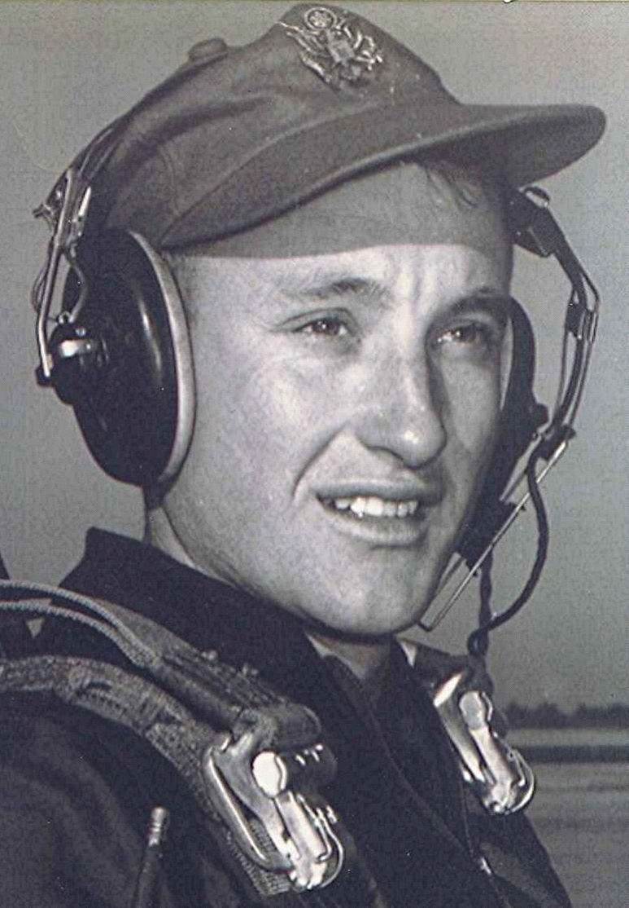
Free at Last!
At the end of six weeks, their tormentors graduated and new group of 'rainbows' showed up to become their lower class. It is difficult, if not impossible, to explain what it was like to go from being the lowest form of life to the exalted position of an upper classman. Even more dramatic was the fact that this change came almost overnight. Where they once traveled only in groups, closely monitored and with their eyes caged, they now could walk anywhere they wished; could look around and do almost anything they desired as far as the freedom to move about. The lower class bowed and scraped before them to the point of embarrassment. Needless to say, the last six weeks were almost paradise, compared to the hell through which they had just come. The ones who couldn't, or wouldn't, stand the emotional strain and the indignities meted out to the lower class had already departed. Others would be eliminated in the coming months in flying training at one of the several civilian contract flying schools.
From time to time, the Air Force officers would boost their ego by reminding the cadets they were in the top three percent of their age group in the United States. He never understood how that was determined, or if it were even true, but it sounded good.
When his group was promoted to upper class, the Air Force commanders convened a board and selected cadets to be class officers. A cadet colonel was selected as the wing commander; his rank designated by the four white elastic bands on each blue shoulder epaulet. While an underclassman, he had a fear of encountering a highly ranked upper classman. He only saw the upper class Wing Commander at special functions such as the Saturday parades, and the rare occasions when the Wing Commander visited the lower class barracks area. The four stripes on each shoulder of the cadet colonel stood out more vividly and caused greater trepidation than the four stars of generals he encountered later in life.
About midway in their training, the Preflight Training School had an athletic field day. That morning everyone dressed in PT clothing and marched to the parade field. Throughout the morning there were numerous contests and games. Meanwhile, a chow hall crew had outfitted a long line of tables with white cloths and had placed large containers of iced tea, lemonade, and other soft drinks on them. Around eleven thirty they brought out the trays of barbecue beef, beans, potato salad, Jell-O, and other desserts and condiments. It was an impressive spread and the hungry cadets eyed the tables with anticipation.
Suddenly they noticed a black cloud approaching from the northwest. It looked strange for a thundercloud. The base of the cloud appeared to be rolling toward them. Suddenly someone shouted for everyone to form up and head for the barracks. The sand storm enveloped them just as they were about to depart. The black Texas soil had been picked up by the whirling winds and carried along in a stifling mass as it rolled across the prairie. The potato salad, beans and everything else was coated with black dirt left by the storm as it passed.
Sometime during the final weeks at Lackland, Captain Zeiss, told them that a friend of his, who had been divorced and moved back to Ohio, needed her car delivered to her home there. This was good news to a couple of cadets whose homes were in Kentucky. They were very interested in driving the car back to Ohio. The lady would provide money for gasoline and oil as well as food for the trip. The Kentuckians agreed to let him ride as far as Malvern, since there was room and Malvern was on the route to Cincinnati. The day they were to leave, Brockhoff, who was in charge of the operation, brought the car to the cadet area. Altogether, there were four passengers. He doesn't recall who the rest were other than Brockhoff.
The time, 1954, predated the construction of the national interstate highway system, although Texas had some of the better two lane highways in the country. Brockhoff and one of the others had calculated the straightest path between San Antonio and Texarkana. This route turned out to be along mostly narrow, two-lane secondary roads.
They started out in the morning. The car was about five or six years old; a six-cylinder Chevrolet sedan with about thirty thousand miles on it. As soon as the city was behind them, the cadet who was driving set his speed at around seventy miles an hour. Observing the speed with some trepidation, he was afraid the engine would not make it to Cincinnati if that speed were held for an extended time. Actually, he was more concerned about his life than engine failure, but used that as an argument for taking it a bit easier. After some extended discussion about the odds of not making it all the way at such speeds, they all agreed that they should maintain sixty miles an hour.
At the end of the day when darkness approached, they noticed that one of the headlights was aimed off to the side of the road. After driving for some time, they finally found a gas station that was still open. It was in a small town somewhere in northeast Texas. After the light was adjusted they trundled off into the night.
Brockhoff had calculated each step of the trip, where they were supposed to be and at what time. The problem was that he had used sixty miles an hour as their average speed. Anyone familiar with the road system back then would recognize that an average speed of sixty was totally unrealistic, given all the small towns with their speed limits and traffic lights. As a consequence of this miscalculation, they were behind schedule almost from the out-set. Their sense of urgency overwhelmed any caution they may have had.
Between Texarkana and Malvern, a light drizzle set in. It was well after midnight when he got out in Malvern. His last words to the others were to caution them about weather conditions and the crooked road from Malvern to Little Rock.
About two weeks later, after he had signed in at Marianna, Florida, their next training base, he encountered Brockhoff. Brockhoff asked if he knew what had happened between Benton and Little Rock. They were blinded by the lights of an oncoming car and ran off the road, overturning at least once, maybe more. The car ended up on its wheels but would still run. The windshield was partially broken out as was one or more of the windows. Their raincoats were used to cover the openings and they pressed on. Some days later they limped into Cincinnati. Brockhoff related how he delivered the car to the Lady and how shocked she was when she saw it, demolished beyond repair.
He felt a deep sense of shame at having even been associated with the debacle. When they left him in Malvern he had an intuition that they would not make it all the way without trouble. He also recalled Captain Zeiss back at Lackland; how he had told his friend what a fine bunch of young men they were, who would be glad to deliver her car to Cincinnati.

