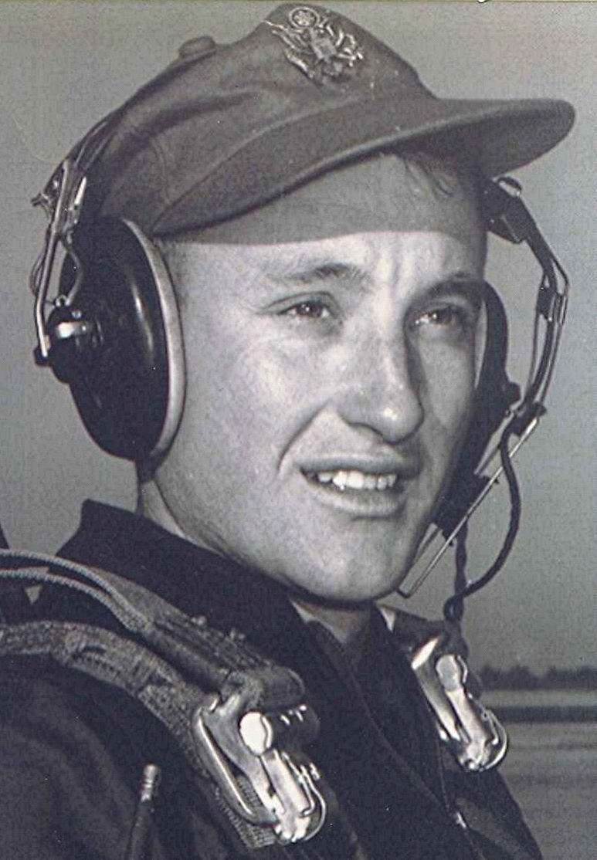
the top three percent
For as long as he lives, he will remember the first morning that he awoke at Lackland. He wondered in the first bleary moments of that day if he had awakened in hell. It was as if he had entered another world and somehow had become a captive in a Japanese prisoner of-war camp. The upper classmen were the enemy. They seemed as tough and hostile as any foreign captor might have been. The lower class could expect neither mercy nor sympathy—only abuse. He still is amazed as to how he managed to survived those first days.
Within a few days they were marched over to the supply squadron where they picked up their uniforms and other gear. The old adage about the Army having only two sizes, too large and too small, was verified by their visit to the supply squadron. They were outfitted according to size, but only approximately, in some cases. Fortunately, his shoes were among the items that did fit. Within a day or two they marched to the laundry and cleaners where they turned in their khaki uniforms to be tailored, removing any excess or loose material. They bought garters at the Base Exchange. These were fashioned into a bungee that stretched from the bottom of their shirts to the top of their socks, keeping their shirts pulled tight and straight. A pleasant discovery was that the elastic attached to the top of the socks and to the shirt tail put a spring in his step as he marched.
They soon learned to keep their foot lockers in constant inspection order. To do this required two sets of shaving items. One was a new, unused set which was only for display and inspection, another one was for his daily use. The daily set was kept in a laundry bag. Other display items such as socks, handkerchiefs, etc. were also duplicated. Following the suggestion of an upper classman, he bought a pair of nylon under shorts at the BX and wore that one pair for the some eleven weeks. The shorts were worn each night while in the shower. That way, they were laundered during the shower and the warm night air blowing in from the south dried them within a few minutes after going to bed. This way, he avoided the problem of any accumulated underwear.
At mealtimes they marched to the cadet dining hall. Where it was, he had no idea, since all eyes were constantly caged, looking only straight ahead. Marching around without being able to look about was somewhat comparable to the plight of a blindfolded hostage. About the only thing they knew about their location was that there were numerous twists and turns in the route. If he had suddenly been turned loose, he most likely could not have found his way back to the barracks.
During meals they were authorized extra rations of fresh fruit and milk, but had little chance to enjoy the privilege. During each meal there were ten cadets at each table— four lower class on each side and an upper classman at each end. One of the two upper class members was designated the "Table Commandant". The tyrant's main purpose in life at that moment was to harass the lower class while they attempted to eat.
There were rigid rules: they sat in a 'brace' while eating, feet flat on the floor and backs straight; buttocks two inches away from the back of the chair and head held horizontal. The eyes could be lowered only slightly while eating, otherwise they must be kept 'caged' to prevent gazing about. An infraction by a lower classman resulted in his being called to attention. The victim of the reprimand had an immediate problem, as he was allowed only three chews before he must swallow whatever was in his mouth. The Table Commandant would yell, "Third gentleman on his right!" (One of the first things they learned was to remember their position, relative to the Table Commandant). Upon hearing this, the one being addressed immediately came to attention, chewed a maximum of three times, then swallowed his food and answered, "Yes sir!" They soon learned to eat only soft food like mashed potatoes, which could be swallowed in an emergency without having been chewed at all. It was disastrous to be called by a Table Commandant with a mouth full of roast beef.
One lower classman at each table was placed in charge of the two metal pitchers which contained juice and milk. These were located at each end of the table. It was the juice monitor's responsibility to insure that they were kept filled. It was considered a serious breach of duty to let the pitchers become empty. Like every other move one made, there was a prescribed ritual through which he must go in order to request permission to refill the pitcher. The one in charge of the juice and milk pitchers could pretty well forget about eating. He dared not let the pitcher (of which he could only guess the level of contents) become empty, yet would be severely castigated if he made the mistake of asking permission to fill an already-filled pitcher. Each dreaded the time when he would be in charge of the pitchers.
There was only one precise and prescribed way to ask for or do anything at the table, even the most simple, such as a request to pass the salt, pepper, etc. During the first six weeks, he ate only soft or semi-soft food, and not a great deal of that. Instead, he concentrated on milk and juice for most of that period. The harassment continued throughout the course of the meal until they gathered in formation and marched back to their barracks.
There was that first morning when they gathered out on the road for inspection. At five o'clock, the charge-of-quarters entered the bay where the twenty-five slept. The CQ switched on the lights and yelled out, "Hit the deck; you have fifteen minutes to be on the road!" The group piled out of the bunks and converged on the latrine. There were only three or four mirrors in the room and everyone was lined up in front of them, six deep. He was fifth or sixth back and tried to maneuver so that he could find a small piece of mirror that was not blocked from his view. Just about the time he could see his face, an arm, elbow or body would shift just enough to block his view; then the maneuvering started all over. After shaving, they dressed and quickly made their way to the darkened street outside, where they lined up for inspection and more verbal abuse for being late. Somehow he survived and learned shortcuts and ways to conserve time to the extent that, later on, he would be on the road waiting, with time to spare.
In their flight there was a cadet named Russell Lund. Russell's mother was the Republican National Committee chairman for the state of Minnesota. His was a wealthy family who lived in Minneapolis. Russell failed his aviation cadet physical but had obtained a waiver from the Air Force Surgeon General. He owned and piloted his own airplane. He was a pale, almost anemic individual. He was friendly, soft spoken, and easygoing and he had serious problems meeting the compressed schedule. Many mornings after the others had shaved, dressed and made their bunks, Russell was still sitting atop his. On their way out to the formation on the road, they would pass Russell: sitting there on the top bunk, slouched over in his underwear, his eyes vacantly staring at the floor.
Demerits were given for each infraction of cadet rules, dress code, or inspection standards. Cadets were allowed only ten demerits per week before they were penalized. Beyond ten, each demerit resulted in an hour's march on the "tour path". The tour path was open for eight hours on Saturday and four on Sunday afternoon. Russell was a permanent fixture on the path. Before graduation, all excess demerits had to be walked off. There were some cadets who had accumulated such an excess of demerits that it was impossible for them to walk them off before graduation. Those who couldn't were "washed back" to the class behind them in order to complete their hours on the ramp.
After breakfast each week-day morning, the cadets marched to the academic building for their classes in Customs and Courtesies; Math; Science; History and Tradition; and Officer Training. The classrooms provided a welcome respite from the harassment of the upper classmen. The lower class had certain members designated as training officers. These their class members were section and squadron leaders. They conducted the marching and the drills. Most were people who had prior service in some branch of the military.
Every lower class cadet was the object of discipline from anyone in the upper class, regardless of time or place. There were some upper classmen who seemed to have sadistic tendencies. They were all too eager to inflict abuse and emotional pain on the lower class. After his group advanced, some of his own classmates exhibited the same tendency in their treatment of their lower class. There were a couple of people in pre-flight who were so unique that he remembers them, many years later. One arrived at Lackland with hair that was extremely long by 1954 standards. It hung down to his shoulders. A few years later, such a thing would be commonplace; however, back then it made the owner conspicuous in the group of newcomers. The long haired cadet was immediately tagged "The Violin Player." Naturally, he was singled out for special treatment and torment by the upper class. The situation was resolved within a few days when everyone marched over to the base barber shop for a haircut that can only be described as akin to that of a peeled onion. After that, The Violin Player could not be distinguished from the rest of the crowd. However, he left within a couple of weeks. Those who couldn't endure the rigors were given the opportunity to "SIE," to leave by way of Self Initiated Elimination.
As they stood in line waiting for the shearers to scalp them, he felt resentment at having to pay his own money for the ignominy. There was a sign on the wall that stated, "Each person must be in the chair at least three minutes." He entertained the thought that the barbers might really be sheep shearers who worked at the Base Exchange during their off-season. After all, how much skill does it take to clip someone's head down to the scalp? Even at fifty cents a head it must have been a lucrative business, each victim taking only three minutes of the barber's time.
Another cadet, a Mr. Langham, (all cadets were addressed as 'Mister') was older than the others and was pushing the age limit of twenty six. He had a master's degree in psychology. It served him well during all the hazing and mistreatment. He was immediately singled out because of education and age, but frustrated his tormentors by standing with a hint of a smile playing at the corners of his mouth while they heaped abuse upon him. His reaction only infuriated them more and heightened the level of their anger. Slowly but surely, Mr. Langham won this war of wills. By the time they graduated he had become a class leader, although he accepted that role rather reluctantly.
Three times a week the cadets ran, in formation, to the physical training field some miles away. They were dressed in government issued athletic shorts, with white tee shirt and tennis shoes. It was in August and there had been no rain for months. Huge cracks laced the black gumbo soil that expanded and contracted with the presence or absence of moisture. Small tufts of struggling grass gave way to the more robust stickers that had taken over the combination parade and athletic field. Large black ants, some of them approaching an inch in length, darted about while seeking refuge in the cracks in the ground.
At each field there was a white wooden platform, standing some five or six feet above the ground. Two enlisted jocks from the base physical training unit awaited the arriving students. Early on, it became apparent that they had an intense dislike for their charges, probably because the cadets were training to become officers. The jocks were dressed in tee shirts and shorts. Their muscles, developed over many hours in the base gymnasium, rippled under skin burned a deep bronze by the hot Texas sun. The cadets couldn't tell what rank the instructors held, but their attitudes were superior. There was no rest upon arrival. One of the jocks immediately mounted the platform and began a frenetic demonstration of athletic prowess and skilled cadence as the cadets attempted to keep up.
The soil temperature approximated that of the top of a cook stove; the sweat rolled off bodies that groaned and ached from the exercise. After ten or so minutes, the first jock swung down from the platform, Tarzan fashion, but not before being replaced by his partner. The fresh jock then joined in the count and the action continued without missing a beat, somewhat like passing the baton in a relay race.
Besides the two athletic specimens, there was a master sergeant with a beer belly that draped over his uniform belt, hiding the silver buckle beneath. During the calisthenics he walked through the ranks of the sweating cadets as they did their push ups, side straddle hops and jumping jacks. The sergeant held a batch of demerit slips in his hand and threatened to ticket anyone whom he considered to be slacking off in any way. The irony of an out-of-shape sergeant issuing demerits for failure to exercise properly was not lost on the trainees.
The tiring cadets grew faint and dizzy from the strain imposed by the double-teaming. If any words of protest were uttered—and there must have been many—they were kept low enough that the captors couldn't hear. The shadow of the porcine sergeant moved across the parched field like that of a giant condor, searching for prostrate prey. Some of the less hardened were beginning to collapse on the ground. The master sergeant walked among them, issuing invectives and demerits. Meanwhile, he felt sorry for his cadet classmates from the city who arrived at Lackland in rather poor physical condition. Fortunately for him, his stint in the log woods the previous fall and spring had somewhat prepared him for the rigors. Even at that, there were times when he felt he would collapse from exhaustion.
After some thirty five or forty minutes of calisthenics, the flights reassembled and started for the barracks. On the way back, the columns were ragged and erratic. One day, not too long after the start of training, Russell Lund made it only as far as the front door. There he collapsed on the floor of the lobby.
Captain Zeiss, the Tac Officer, came over to investigate. At the next PT class, there was an older trainee in the ranks. It was Captain Zeiss, incognito in shorts and tee shirt, but looking rather mature for a cadet. He had come to observe the proceedings. That evening the trainees were told to turn in all the demerits issued by their master sergeant friend. These were trashed.
Somehow, the cadets endured the physical training while losing a lot of excess fat in the process. One in particular, who was from Brooklyn, had arrived at Lackland resembling a large pear. He must have lost close to seventy pounds. The day they packed, in preparation for leaving Lackland, Furillo produced the pair of pants that he wore the day he arrived. He put them on and the waistband extended about eight inches out in front of his now-lean body.

