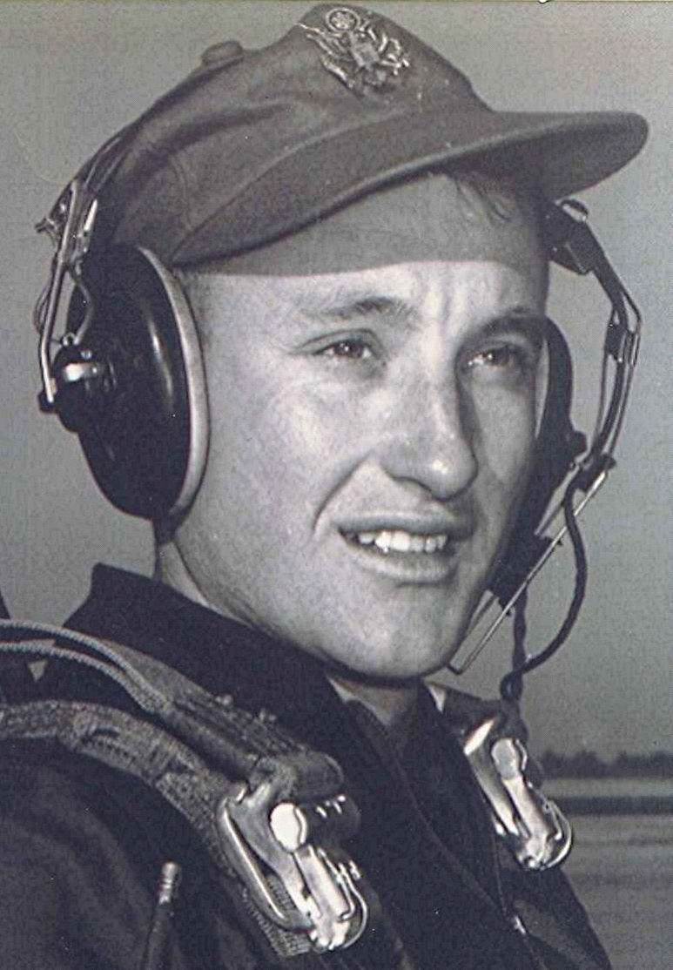
July 2, 1954
Reporting time at the Armed Forces Induction Center, a two story gray building in downtown Little Rock, was seven in the morning. The overnight coolness lingered as the sun's first rays reflected off the concrete and asphalt. This was his first exposure to what would later become a familiar routine, the hurry-up-and-wait of military bureaucracy; after reporting, the inductees waited for nearly three hours before the processing began.
They were given yet another medical history form to be filled out; with the boxes to be marked yes or no: Have you ever ... Does anyone in your family ... Is there a history of ... and other inanities such as, "Have you been treated by a doctor?" He mused over the likelihood of there being anyone in the United States who had not been treated by a doctor. The inductee ahead of him in the line answered "yes" to several questions pertaining to: suicidal tendencies, a history of insanity in the family as well as other undesirable traits. The presiding doctor, upon reviewing his answers, stamped "passed" on the inductee's paperwork after asking a couple of cursory questions. Observing that, he wondered what would it take to disqualify someone.
Following this, everyone was given a pre-induction physical. Compared to the cadet physical at Lackland last spring, this one was mostly procedural. As long as the light from a flashlight directed into one ear didn't emerge on the opposite side or there was a collection of moisture on a mirror held to the mouth, they passed.
About three or four that afternoon they were through, with travel vouchers in hand for military bases in different parts of the country. There were four or five who were destined for Lackland Air Force Base at San Antonio, Texas. He was the only one from that group who was joining the Aviation Cadets. The others were all headed for basic training. The oldest, Dacrus Parker, had been in the Army or the Marines Corps, and was re-enlisting in the Air Force. Dacrus was to attend a refresher course at Lackland. Since he had prior military service, he was placed in charge of their group.
Their train was not due into Little Rock until later that night, so they decided to go home with Dacrus. They took a taxi to his home across the river in North Little Rock. When they arrived there the taxi driver tried to overcharge them. A shouting match started between Dacrus and the driver. Dacrus did most of the shouting. Finally, the driver gave up, now willing to take whatever Dacrus thought was fair. They were obviously in the capable hands of someone who knew his way around.
The train pulled into the station down on Victory Street in Little Rock around ten that evening, the light from inside the Pullman cars casting patterns of light and shadows on the station platform. Inside, the incoming passengers were making preparations for bed. He had never ridden a train before, but any apprehension was dispelled by the presence of the other neophytes and the confident guidance of their new leader.
When they boarded, the conductor informed Dacrus that there weren't enough open berths for everyone. Therefore, two of them would be given a private compartment. Dacrus took him aside and said, "Don't say anything, but you and I are going to take the compartment." As they prepared for bed, the others missed the two of them. Suddenly there was a loud and persistent knocking on the compartment door. When the door was opened, there stood the others in the group, who stuck their heads inside and looked around.
Noting the private accommodations, they shouted indignantly, "Hey! What is this? How do you two guys rate a sleeping compartment?"
After the others finally left, he undressed and crawled into bed. The train stopped and started periodically throughout the night. Sometimes this was accompanied by banging and hammering noises, as if someone were working on it. He slept fitfully as they traveled though Texarkana and on to East Texas. Early the next morning they stopped at a small town somewhere between Texarkana and Waco. The conductor said if they wished, they could go across the street from the station and shop. A large pile of watermelons stacked beside the depot reminded him that it already was watermelon season in east Texas. These were apparently waiting for shipment. After a twenty minute or so delay, the passengers re-boarded and the train and continued on its way.
During the morning their group moved from the Pullman to the observation car. It had an elevated seating area with forward-facing windows overlooking the other cars in the train. By this time they were passing through scattered rain showers. The overcast skies and freshly washed greenery of the countryside made this portion of the trip very pleasant. Meanwhile, Dacrus was busily moving about the train, talking to anyone he could engage in conversation. Once, an irate conductor saw him standing on the open steps of the passenger car as it sped along the rails. The conductor, in no uncertain terms, ordered him to get his *** back inside. During the morning some in the group noted that the seat of Dacrus' pants were split. He continued his visitation and wandering, never the wiser. Because of some perverse sense of humor, the others didn't tell him about his problem.
Hours later they pulled into the station at San Antonio. The skies had cleared and the bright Texas sun beat down on the asphalt. Outside the station there were several blue Air Force buses waiting. As soon as those going to Lackland for basic training got off the train, they were corralled by airmen from the base who directed them to the busses. Among the group from the Air Force base were white gloved aviation cadets who gathered the new cadets into a separate group and directed them to their bus. He then discovered that there were several other new cadets who had been on the same train. They were from various places up north. Once the bus was loaded they headed out of town along a highway lined with palm trees, dusty adobe storefronts, and assorted shacks. The July heat shimmered in waves off the highway ahead, the air was hot and heavy. At that moment, perhaps none of them understand—or even suspected—what awaited...

