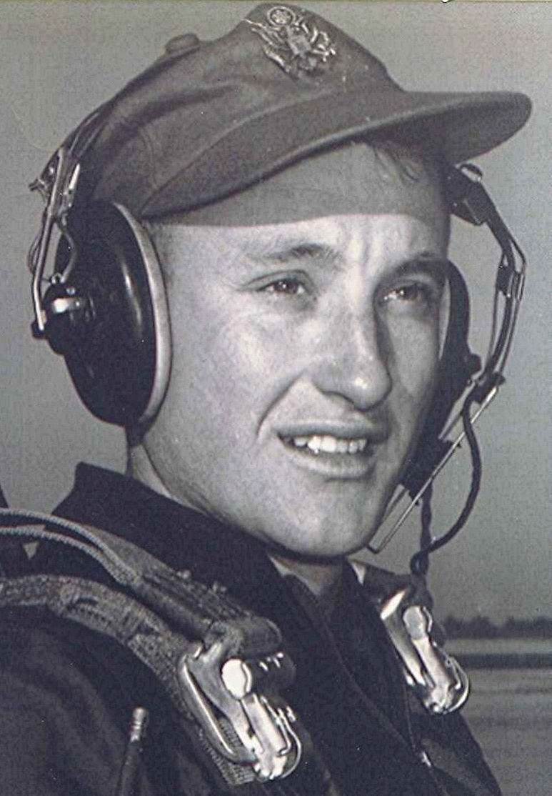
recollections of a fledgling aviation cadet pilot
“Where never lark or even eagle flew.”

Awaiting us at the end; an open door to adventure, honor, perhaps even glory, (we thought ...)

Beyond high school; recollections of a fledgling aviation cadet pilot

Abstract
Herein, some of the experiences of a farm boy, entering into a new and sometimes baffling world, far different from the familiar one left behind at Holly Springs, Arkansas.
Our own feeble words sometimes fail us as we attempt to convey the wondrous sensations; of being free of the bonds of gravity; soaring among cathedrals of billowing clouds against a backdrop of deep blue sky...the following poem by an airman who was killed shortly after he wrote it, says it more beautifully than one could ever have hoped.

High Flight
Oh! I have slipped the surly bonds of earth,
And danced the skies on laughter-silvered wings;
Sunward I've climbed, and joined the tumbling mirth
Of sun-split clouds, –and done a hundred things
You have not dreamed of –Wheeled and soared and swung
High in the sunlit silence. Hov'ring there
I've chased the shouting wind along, and flung
My eager craft through footless halls of air...
Up, up the long, delirious, burning blue
I've topped the wind-swept heights with easy grace
Where never lark or even eagle flew –
And, while with silent lifting mind I've trod
The high untrespassed sanctity of space,
Put out my hand, and touched the face of God.

~ Pilot Officer John Gillespie Magee, Jr

