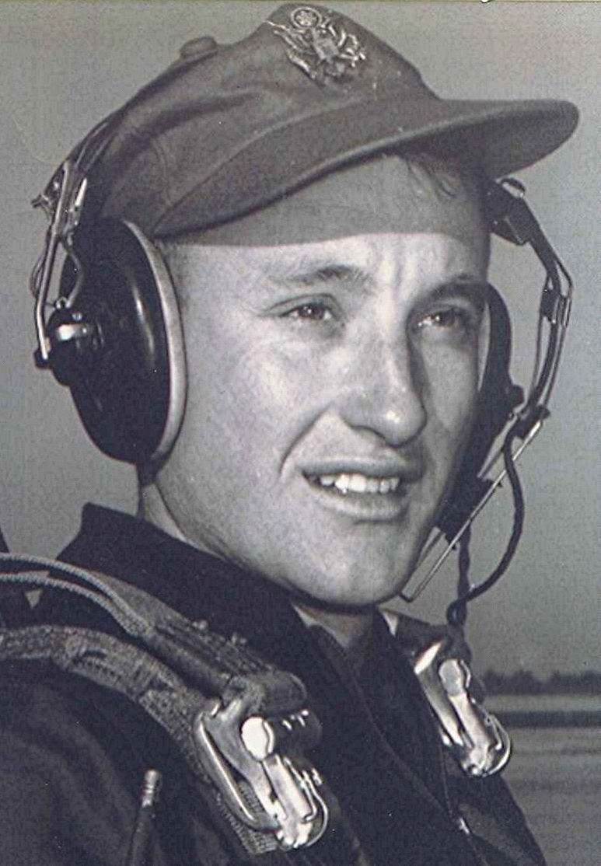
Another Story From Holly Springs
I recall this incident happening when I was either in high school or shortly afterwards: We rented a so-called "stationary" hay baler from Mr. Cad Patterson; one that has a huge gear driven by the belt attached to a farm tractor. The main piece of machinery on the baler was a very large "Bull Gear" which drove the compress.
I, being the oldest and wisest, was the head of the three-person crew that set out to bale a field of hay. My two helpers consisted of Jerry House and Fred Terry Watson. I don't recall which one of the boys was responsible for placing the oak blocks that divided the bales of hay in readiness for the tying-off, but they must be adroit in dropping the heavy oak blocks into the hopper at the right moment.
Well, to make a long story longer, on the first bale the blocker waited too long to drop the block to separate the bale. Consequently, the compress caught the block half way into the chamber and half out.
Since there was no clutch on the bull gear it continued to grind off about ten inches of teeth before we could stop the tractor and belt. We never even got to bale one bale of hay and worked half a day to dismantle the baler and remove the gear. Fortunately, as Bob Abbott pointed out, in those days one could find a machine shop that could restore the gear teeth. I don't recall what it cost for that first bale (which never made it through the baler); nor do I know what Mr. Patterson's reaction when he found out what happened to his nearly new baler.
To ad insult to injury, Fred Terry, not being very familiar with the hand clutch of the John Deere tractor, failed to stop in time and drove it through the closed gate on our way out of the field. By this time I was beside myself and ready to fire them all.

