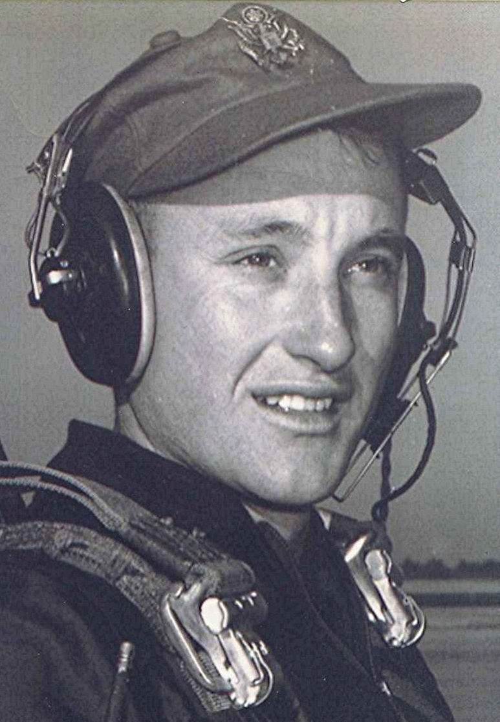
Leland Clauson “Porkie” Roberts
Thursday, January 1, 2006
PINE BLUFF — Leland Clauson Roberts, 75, of Pine Bluff, Arkansas, died Thursday, January 26, 2006, at Jefferson Regional Medical Center. He was born July 20, 1930, in Dallas County, a son of the late Leslie Clauson and Martha Mae Albritton Roberts. He was reared and received his early education in Dallas County, graduating from Sparkman High School.
Mr. Roberts was a U.S. Army veteran and a member of Northside Baptist Church. He had worked for the Arkansas Department of Correction, retiring as Captain in the Kitchen, at the Tucker Maximum Security Unit.
He was preceded in death by his parents, wife, Edna Garrison Roberts, step-son, Randy Karl King, and grandson, Russell Morton. Survivors include, two daughters, Leslie Shea McDaniel, Joyce Yelverton, both of Pine Bluff; two sisters, Adele Stone of Hot Springs Village, Leslie Jean Quarrels of Holly Springs, five grandchildren and four great-grandchildren.
The family will receive friends after the service, at Robinson’s. Services will be 10 a.m. Saturday, January 28, 2006, in the Chapel of Ralph Robinson and Son, with Chaplain John Hagin officiating. Private burial will follow in Holly Springs Cemetery in Dallas County. Memorials may be made to donor’s choice.

Personal Note:
Clauson Roberts was a Holly Springs kid. A couple or more years ahead of me in school. Probably more like three or four. His nickname was "Porkie". Had a horrible case of acne when he was a teenager which disfigured his face. His Mother was the Post Mistress at Holly for years and years. His father built and operated the grocery store on the west side of the highway at one time. He lived in Pine Bluff for years. Owned a Cafe there once, if I recall. Before that, he and his wife operated the store in Holly Springs next to Pauline's for a short while. That was a long time back.
Once, when I was a little fellow, I walked to Holly (two miles or more) to buy something from the store for Momma. I recall vividly that Porkie and Junior Gurnsey were riding horses and swooped by me, taking my straw hat, which they then threw up into a tree where it lodged. I went home without it, of course. As you well know, in those days a straw hat was an important part of a farm boy's attire. I will never forget that.
I never saw Porkie after he moved away. Not too long before Pauline's [Boyd’s cousin] death he came to see her at Holly Springs.
Boyd

