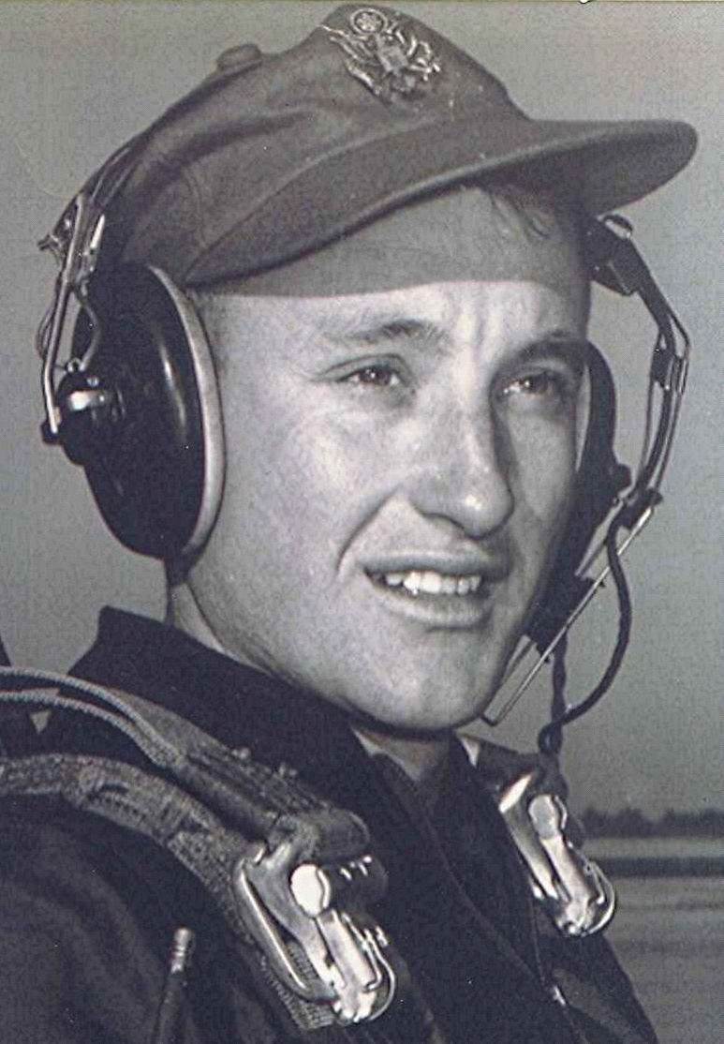
Savannah, Georgia
September 10, 1989
Having just finished talking with Jane, my mind creates a scene of home, with the rain softly falling, the sky leaden and low with wisps of fog touching the tops of the pecan trees in the corner of the field near the neighbor's house.
Soon it will be time for the frost to fall, and shortly thereafter the leaves will cascade down as the wind gusts shake them from the trees. Fall always had a special appeal to me as a youngster on the farm. It meant a time of harvest, and I can still re-live the wonderful sensation of how great it was to be alive at that time of the year. The mornings would be cool, even cold, but by noon it would warm just enough to make the sun feel pleasant on my back. Often, we would be picking cotton, and at the end of the day, as the sun set, the slight chill once again settled on the land. Then to plunge headlong into the pile of cotton in the back of the wagon, with the softness and the clean smell enveloping me as I lay there resting and enjoying a brief reverie.
Having lost my sense of smell some years ago, I find myself trying to recreate in my mind some of the many scents that accompanied fall. With that, I am abruptly reminded of my inadequacies and limitations when I try to convey to another being, my experiences, my thoughts and sensations. I suppose the depressing thing is to realize that I can never pass on to my children the experiences with which I was blessed on that farm.
Has it not been said that there is an innate sense in the elephant to return to a certain place to die? I feel a relationship with that part of the earth that will remain with me till my last dying breath. I am a product of that piece of God's world and remember the wonder I felt while roaming the pastures, woods and fields of that place, I would stop and study the meanderings of an insect, or the beauty of a flower, filled with awe at the magnificent things nature laid before me.
I sometimes think I have come full circle. From the farm to the world, and then, to return to the land. Could it be that truth lay there before the boy, who immersed himself in all the panoply and glory of rural life? Somehow, I believe that the small boy was closer to the Truth there than in the years to follow. Books are invaluable for exercising the mind, transferring the treasure of thought, and enriching the life. Some things transcend literature, letters, expression. For a brief few years, (though then they seemed forever) I was blessed with the unique opportunity to share with God his magnificent world, in a way which I will never again be able to recapture, for the years cannot be regained, once having passed beyond.
[See “Richard Boyd Dodson 072.00 ~ WVB ~ miscellaneous reflections = far from home on a rainy day” for a slightly different version of this memory.]

