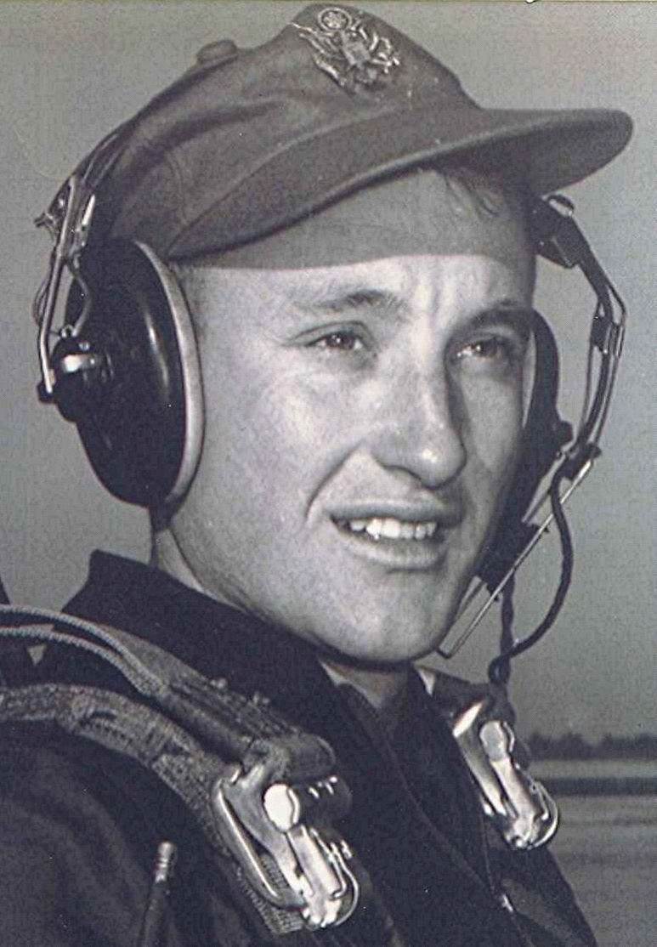
Time, Black Holes, and Other Considerations
From: The Seekers
September 1996
Not for us are content, and quiet and peace of mind,
For we go seeking a city that we shall never find.
Only the road and the dawn, the sun, the wind, and the rain,
And the watch fire under the stars, and sleep and the road again.
We travel the dusty road till the light of day is dim,
And sunset shows us spires away on the wide world's rim.
We travel from dawn to dusk, till the day is past and by,
Seeking the Holy City beyond the rim of the sky.
~ John Masefield ~

