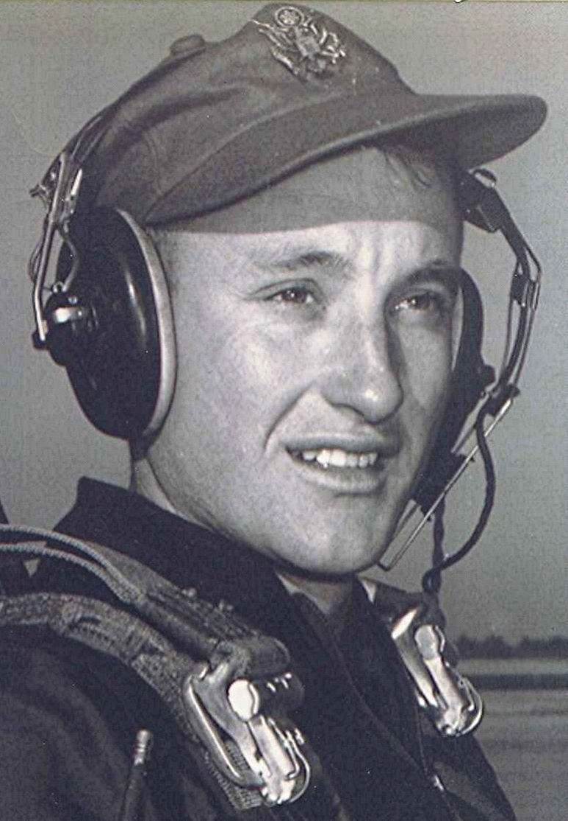
Time, Black Holes, and Other Considerations
Crossings
September 1996
The turning of the seasons reminds us of our mortality in a way that is difficult to ignore. The shaking of the leaves in the November winds signal their imminent falling away. Following that, the winter will come, when the earth sleeps, awaiting the resurrection of spring. When the next generation springs forth to glorify and declare the grandeur of God, the leaves of this fall wont be there. Others have taken their place as time unfurls and marches toward eternity.
Time; at one, the great mystery and the enemy of us all, but the sustainer of our existence.
Time, and the winding down of the universe has intrigued the greatest minds as well as others of us with just enough intellect to make us miserable. Caught on the horns of the dilemma of desperately wanting to understand, but unable to with the abilities that we were issued, we struggle with bits and pieces of the picture.
Take the theory of Einstein's that speed and light and size and time all have a connection. That men orbiting at great speeds through space will return to earth a minuscule younger than their counterparts. That after traveling near the speed of light for years, space men would return to earth to a world grown much older while they were away, their children perhaps now older than the parent that was on the space ship whose clock, literal and figurative has slowed in relation to those on earth.
What does that mean? Is time flowing past us at the speed of light so that if we attain that speed, time for us, in essence, would stand still?
We know from experience that two hours can be very different in length. Compare the hour spent in the presence of one we love as opposed to an hour enduring the pain of an abscessed tooth. Or the last fleeting hour before boarding a plane that takes you away to some foreign war from which you may never return. Which is the truer measure of time, those or the mechanical cycling of the clock?
Does time move past us, or do we move past it? If all through eternity is fixed, somewhere back there is the beginning (of time) and out there somewhere is the end. We are somewhere along the way between beginning and ending; analogous to the reel of movie in the can that has an already—fixed beginning and ending, but we see only one frame at a time as it moves by us or we move through it; and that is our reality.
I think of one concept of time as likened to a tree beside a river. The tree sees only the present; the past has already flowed by and is now irretrievably downstream; the future remains upstream, unseen and yet to come. The other concept is that of time being static and we, the actors, moving along through it, much as a traveler down an unfamiliar road. We know and can only prove that which we witness; the road ahead we believe to be there but can't be certain and the road behind us, we believe still remains, but again not really knowing for certain.
Somewhat along this line, Isaac Asimov entertained the idea of moving forward into the future or back into the past. An argument could be made that to move back into the past is impossible, if for no other reason, because that would change events already fixed. For example if one went back in time and killed one's own future father. On the other hand, moving into the future poses no such contradictions, since from our perspective, the future hasn't yet happened and, as such, events are not already filmed and in the can—or are they?

