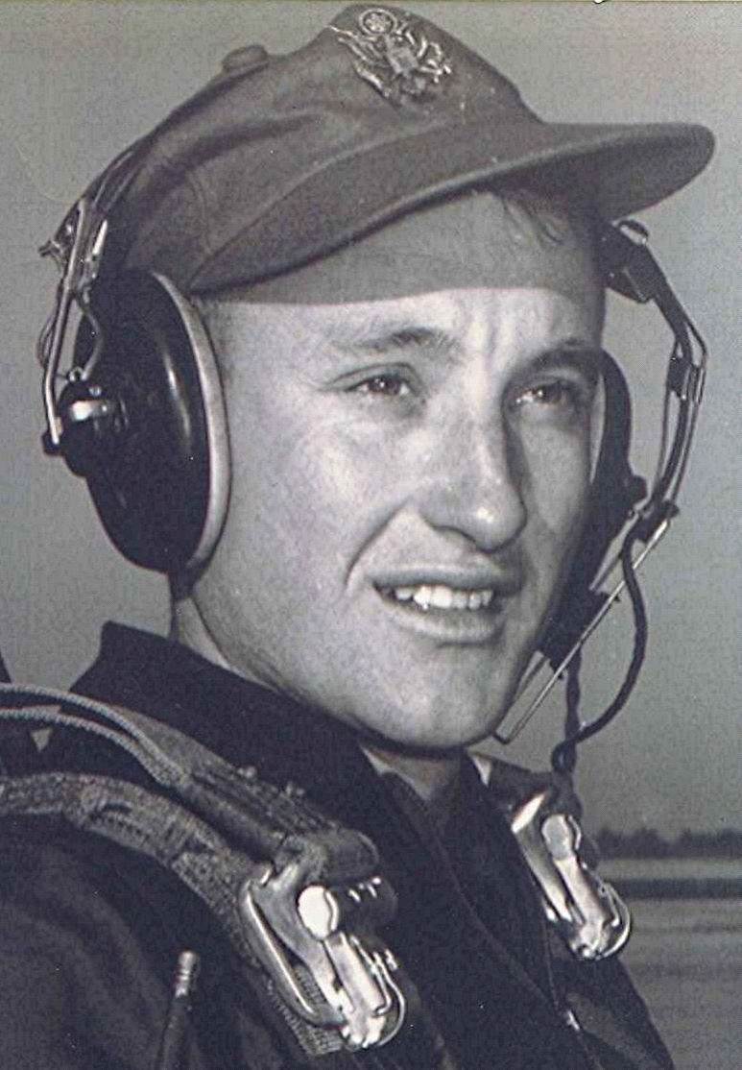
Remembering Mrs Ruth Buzbee Yeager
Picked up one of the intermittent copies of the Arkansas Democrat-Gazette today and noted the death of a school teacher of mine who taught at Holly Springs back in the thirties. Mrs Ruth Buzbee Yeager of Fordyce, was Miss Buzbee when I started to school at Holly in 1939. She was the principal of the two-room, eight grade school that stilt stands today much as it was then. Miss Buzbee taught grades five through eight. Miss Buzbee and the other teacher, Miss Alice Oakley, shared rooms they rented from a local resident. We kids, who had a distorted sense of what constituted "old" sometimes referred to the two young single teachers as "old maids." My calculations indicate that Miss Buzbee would have been in her late twenties back then. She married Lloyd Yeager while still teaching at Holly, but in our minds she was still "Miss Buzbee." In 1944-45, the upper four grades from Holly Springs were consolidated with Sparkman, interrupting my time under Miss Buzbee's tutelage and limiting it to one year.
As is so often the case, when noting the death of a significant person out of my past, memories came calling. Probably the most vivid, in addition to that of Miss Buzbee standing on the front porch of the school, ringing the bell that called us to line up in front of the steps, was the day I had a head-on collision with Maurice House. I was still in Miss Oakley's class at the time, maybe six years of age. I was running full-tilt around the corner of the brick building and Maurice was coming in the opposite direction at the same rate. Our heads met with a crash and I came out the loser. A hen-egg-sized knot popped up on my forehead, and it hurt bad. I started bawling and ran back to the front of the school, seeking consolation from a teacher. Recess was over and I stood on the porch with Miss Buzbee as she rang the bell, clinging to her wool plaid skirt; tears streaming down my face.
She was a beautiful woman with creamy complexion and dark hair, always dressed and manicured to perfection. I either had been told or imagined it, that her exquisite complexion was due to her Cherokee ancestry. She and Miss Oakley were from a world quite unknown to me, and I would guess, most of the rest of us. They were educated and by Holly Springs standards, cultivated and refined. To me, one of the most striking thing about these two teachers were their hands. They weren't calloused and worn from farm work and household drudgery like most of the other adult women I knew. Theirs were soft with painted nails, and wrote with a penmanship superior to anything I had seen before.
Miss Buzbee's refinement notwithstanding, she was a strict disciplinarian. Even more remarkable that a young woman could enforce unquestioned discipline, when some of the older boys could have been considered adults. A few had flunked several times on their laborious journey to the eighth grade.
Something happened during recess that caused Miss Buzbee to shrink our playing area by approximately half. We could no longer range down to the ditch and the spring, nor could we mess around under the tall pine trees back of the Baptist church. All that off limits, except that we could still stand on the new boundary, the road that went past the school and down thru the hollow, and try to throw rocks over the towering roof of the church.
According to her obituary, Miss Ruth taught 39 years at Fordyce after leaving Holly Springs.
R.I.P....
[Editor’s note: Fordyce, Arkansas, USA ~ Holly = Holly Springs, Arkansas, USA]

