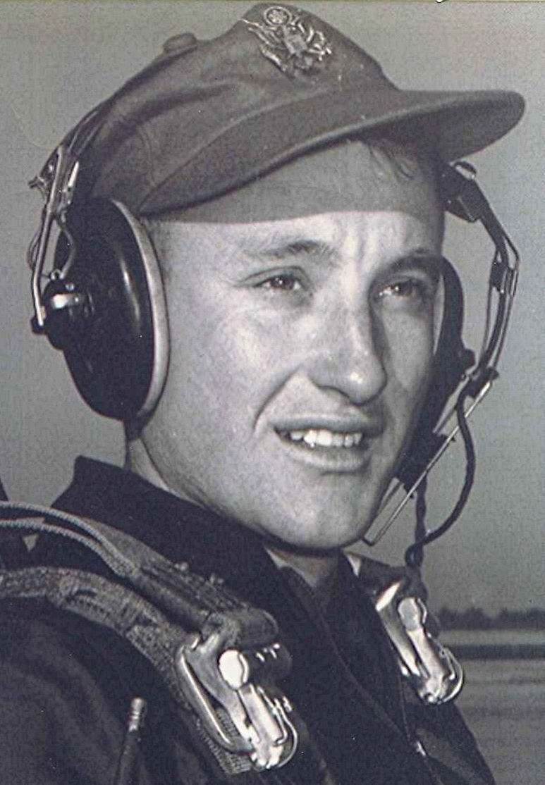
When Doctors Made House Calls
I recall the smells of medicine in Doctor Taylor's office in Sparkman, that also served as a drug store. His examination room, although it wasn't called that, had no doors for privacy, just openings in this small cubicle, where those waiting out in the drugstore could hear all the conversations between doctor and patient,
I recall as a child, that when he made house calls his hands were always cold; not realizing till much later why that was. He was bald headed, and ruddy complected. Spoke in a loud voice most times, probably from shouting at all the old deaf patients. No nurse, his wife helped out sometimes, but Doctor Taylor administered his own shots and did all the bandaging and setting and everything like that. Gave me a shot one time that caused pain to resonate from the tips of my fingers all the way up to my shoulder socket and on beyond, Lord knows where that nerve went to.
Rough, gruff, but a heart of gold. Even took eggs and chickens sometimes in payment. When he died, practically everyone in two counties owed him money; most of them he had delivered when they were born. Wasn't a wealthy man by any measure, except that he was the most singularly admired man in that part of
Arkansas.

[Editor’s note: Sparkman, Arkansas, USA]

