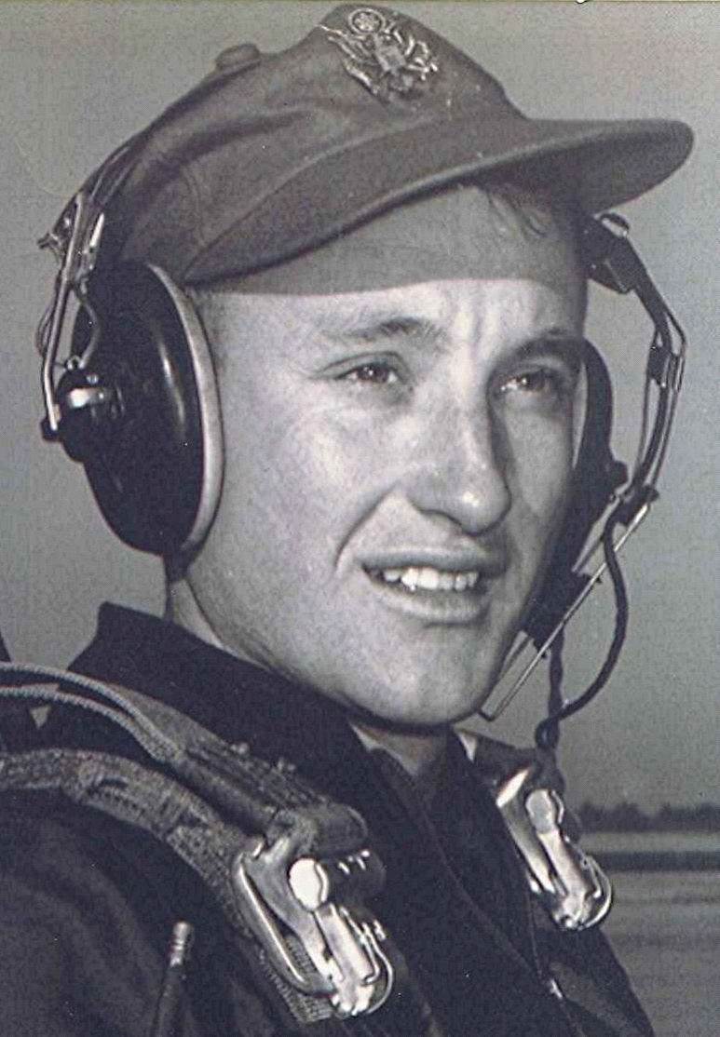
Brief Bio of Boyd Dodson, by Boyd Dodson
The essay October Doxology, written in October 1992, is from a collection of memories titled "Where Violets Bloom" by the author who lives in Dyer, Arkansas. Boyd graduated at Sparkman in the Spring of 1951 and enrolled at Southern State College that fall. He became disillusioned at the prospect of sweeping the armory for four years for room and board and withdrew after six weeks. He returned home, helping his father on the farm while sawing timber in the logwoods with a power saw, at that time a recent innovation in the logging community.
While at work in the logwoods, the sounds of jet aircraft wending their way across the skies of South Arkansas motivated him to look up and ask: why not me? Fortunately, at that same time the Air Force needed pilots to the extent that they were accepting high school graduates as candidates for flying training-if they could pass the stringent entrance exams-which he did.
He graduated from flying training in October, 1955, and was presented a Distinguished Graduate award along with being commissioned as a 2nd Lieutenant and pilot. He served at various locations across the United States and in Spain over the succeeding years and spent a year in Vietnam. There he was awarded, among others, The Distinguished Flying Cross. During his career he flew ten different aircraft varying in size from the B-52 to his favorite, the C-7 Caribou (Vietnam). It was a short-field airplane, designed to land and take off from dirt runways as short as 1,000 feet in length.
In 1975 Boyd retired after twenty-one years of service and resumed the college study that he interrupted some twenty-five years before. In 1979 he graduated Cum Laude at the University of Arkansas, Little Rock.
~ Boyd Dodson

[Editor’s note: Sparkman High School, Sparkman, Arkansas, USA ~ Southern State College, Magnolia, Arkansas, USA]

