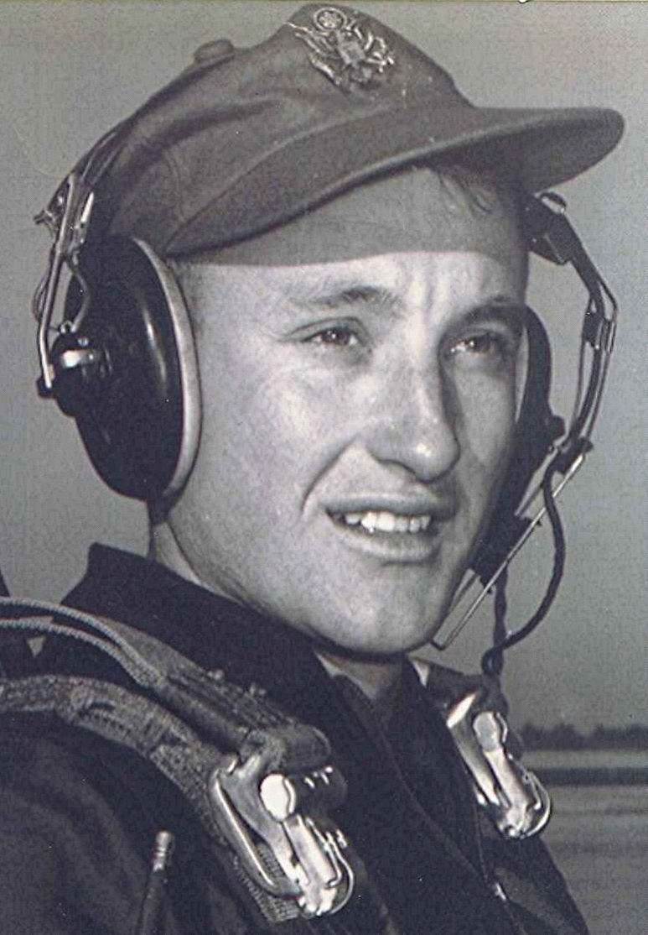
Veteran’s Day
November 1988
Didn’t do anything extraordinary this Veterans Day. Not that I usually do, since the main thing that brings out the fact it is being celebrated at all are the bank and post office closings. Oh, there were the usual ceremonies at the different memorials around the country, including some of the national cemeteries like the one at Fort Smith [, Arkansas, USA]. Where the usual vacuous speeches were trotted out by politicians, most of whom have never lifted a gun or even strapped on a canteen in service of the country which so generously provides them with a standard of living that would make an archduke envious.
I suspect there were far more non-veterans taking the day off than the veterans for whom the day allegedly is designated. But that is nothing new. I recall a Christmas Day in Vietnam. It was just another work-day for us, I made several stops at different firebases and forward sites in the highlands that day, delivering supplies, ammunition, etc. I don’t think there was a single Vietnamese on duty at any of the landing strips where we stopped; only Americans. The irony of it struck me; being halfway around the world, working on the most important holiday we Christians celebrate, while the locals who perhaps were mostly of another religion, took the day off.
But a soldier can’t dwell on the inequities he encounters while attending to duty, honor and country. Most, I suppose, keep going in the face of danger, separation and loneliness when far from home, by having a vision of someone they love or some dream to which they hope to return when the business of killing and being killed is finished. Such was the soldier whose letter to his wife is set out below.
The first time I read it, I almost couldn’t finish it.
Letter from a Union Soldier
http://www.civil-war.net/pages/sullivan_ballou.asp
July the 14th, 1861
Camp Clark
Washington, DC
My very dear Sarah:
The indications are very strong that we shall move in a few days - perhaps tomorrow. Lest I should not be able to write you again, I feel impelled to write lines that may fall under your eye when I shall be no more.
Our movement may be one of a few days duration and full of pleasure - and it may be one of severe conflict and death to me. Not my will, but thine 0 God, be done. If it is necessary that I should fall on the battlefield for my country, I am ready. I have no misgivings about, or lack of confidence in, the cause in which I am engaged, and my courage does not halt or falter. I know how strongly American Civilization now leans upon the triumph of the Government, and how great a debt we owe to those who went before us through the blood and suffering of the Revolution. And I am willing - perfectly willing - to lay down all my joys in this life, to help maintain this Government, and to pay that debt.
But, my dear wife, when I know that with my own joys I lay down nearly all of yours, and replace them in this life with cares and sorrows - when, after having eaten for long years the bitter fruit of orphanage myself, I must offer it as their only sustenance to my dear little children - is it weak or dishonorable, while the banner of my purpose floats calmly and proudly in the breeze, that my unbounded love for you, my darling wife and children, should struggle in fierce, though useless, contest with my love of country?
I cannot describe to you my feelings on this calm summer night, when two thousand men are sleeping around me, many of them enjoying the last, perhaps, before that of death -- and I, suspicious that Death is creeping behind me with his fatal dart, am communing with God, my country, and thee.
I have sought most closely and diligently, and often in my breast, for a wrong motive in thus hazarding the happiness of those I loved and I could not find one. A pure love of my country and of the principles have often advocated before the people and "the name of honor that I love more than I fear death" have called upon me, and I have obeyed.
Sarah, my love for you is deathless, it seems to bind me to you with mighty cables that nothing but Omnipotence could break; and yet my love of Country comes over me like a strong wind and bears me irresistibly on with all these chains to the battlefield.
The memories of the blissful moments I have spent with you come creeping over me, and I feel most gratified to God and to you that I have enjoyed them so long. And hard it is for me to give them up and burn to ashes the hopes of future years, when God willing, we might still have lived and loved together and seen our sons grow up to honorable manhood around us. I have, I know, but few and small claims upon Divine Providence, but something whispers to me - perhaps it is the wafted prayer of my little Edgar -- that I shall return to my loved ones unharmed. If I do not, my dear Sarah, never forget how much I love you, and when my last breath escapes me on the battlefield, it will whisper your name.
Forgive my many faults, and the many pains I have caused you. How thoughtless and foolish I have oftentimes been! How gladly would I wash out with my tears every little spot upon your happiness, and struggle with all the misfortune of this world, to shield you and my children from harm. But I cannot. I must watch you from the spirit land and hover near you, while you buffet the storms with your precious little freight, and wait with sad patience till we meet to part no more.
But, O Sarah! If the dead can come back to this earth and flit unseen around those they loved, I shall always be near you; in the garish day and in the darkest night -- amidst your happiest scenes and gloomiest hours - always, always; and if there be a soft breeze upon your cheek, it shall be my breath; or the cool air fans your throbbing temple, it shall be my spirit passing by.
Sarah, do not mourn me dead; think I am gone and wait for thee, for we shall meet again.
As for my little boys, they will grow as I have done, and never know a father's love and care. Little Willie is too young to remember me long, and my blue eyed Edgar will keep my frolics with him among the dimmest memories of his childhood. Sarah, I have unlimited confidence in your maternal care and your development of their characters. Tell my two mothers his and hers I call God's blessing upon them. O Sarah, I wait for you there! Come to me, and lead thither my children.
Sullivan

Sullivan Ballou was killed at the first battle of Bull Run.

Richard Boyd Dodson comments:
My daughter brought this letter to my attention. She first learned about it while watching the PBS series on the Civil War. It can also be found on the Postal Service web page on the Internet.

