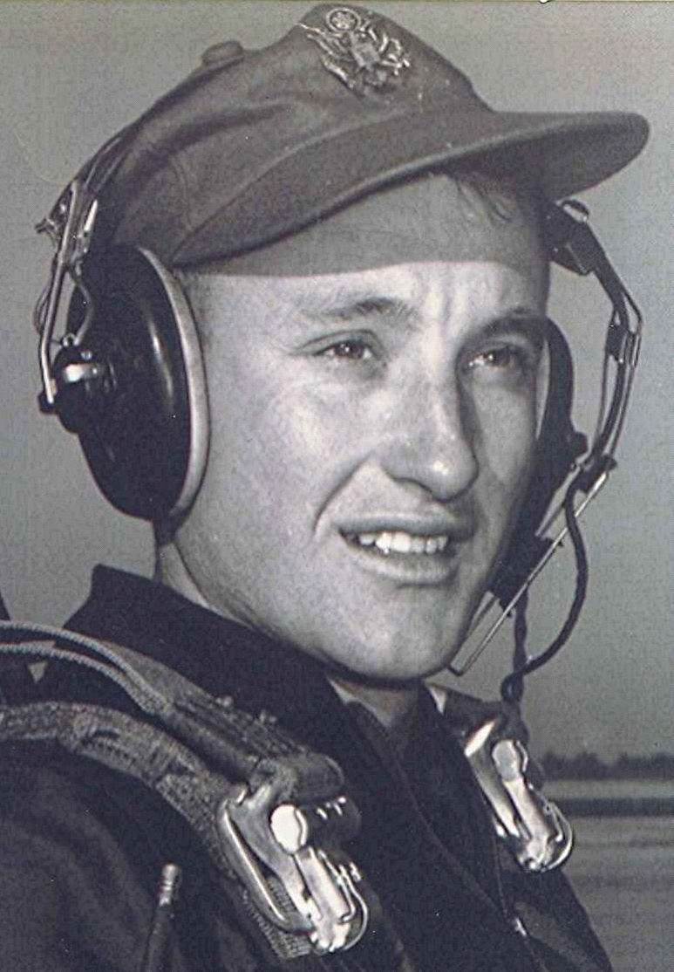
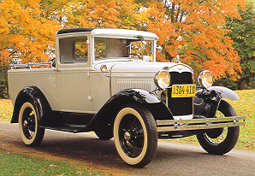Drinking Downstream from the Common Herd
January 1999
One thing that happens with getting older is that my mind has a tendency to revisit corridors and places in the memory that contain those time-enhanced recollections of teenage years. Irrevocably linked with those are the recollection of the courting vehicles of the fifties in rural south Arkansas. Remove the cattle rack, shovel out the sawdust, straw and cow pies and do a quick hose-down and the 49 Chevrolet with the deluxe cab was converted into a courting vehicle. Deluxe having a somewhat different meaning back then. In the case of the 49 Chevrolet pickup it meant that it had rear corner windows—distinctive, nonetheless. The pickup in the picture at the right is 1951 model but the differences were negligible

With a couple or three exceptions all the roads in Dallas county were dirt or gravel. The roughness of the surface, combined with the bouncing of balloon tires caused an up and down whipping action of wheel and tire that resulted, over time, in the creation of thousands of small ridges perpendicular to the path of the vehicle. This corduroy effect was most pronounced on the gravel roads.

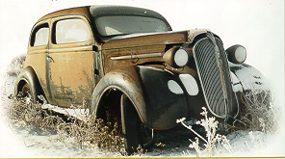We discovered that there were certain speeds at which the wheels seemed to plane along, hitting only the tops of the corduroy ridges, thus smoothing out the rattling chatter you encountered at lower speeds. The 49 Chevrolet rode best at around 45 to 50. Given today’s paved roads, 50 miles an hour seems tame, but on a twisting gravel road with banks of loose gravel piled up in rows between the ruts 50 miles an hour could be a real thrill–besides being downright dangerous as the rear sometimes wanted to swap ends with the front while navigating curves.
1937 Plymouth sits in a field in Iowa after a snowstorm

Back then, I would estimate that most cars and pickup trucks were worn out at forty thousand miles or less. Considering the roughness of the roads, the stifling dust and mud and the infrequency of oil changes, that is understandable. Oftentimes, they were driven long after they were worn out, some requiring the addition of oil ever forty or fifty miles.

The useful lives of vehicles back in the late twenties and early thirties were even shorter, based on total miles. One irony is that their bodies were built of heavy gage metal that lasted for years after their engines quit. These abandoned hulks, some with full grown trees growing up through them, attest to the thickness and strength of the sheet metal from which they were shaped.

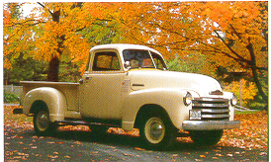Radiators tended to spring leaks from the shaking induced by the rough roads. We had one car whose radiator leaked so badly we carried a bucket and planned our route so that a source of water—creek, spring or mud hole—was available every few miles. If a bucket or can wasn’t available, a felt hat was sometimes used to dip up the water. There was a spring alongside the road just to the west of Fordyce. We stopped there on our way in to town and again when leaving.

Uncle Johnnie Sorrells had a Model A truck similar to the restored one above. The cab was crowded with only two people, so the kids rode in the back. Recall one time returning from a trip to Smead, when Mr. Tom House spit a gob of tobacco juice out the opened right window and I, crouched in the back looking around the cab into the wind, caught it full in the face! Yuuuck!

In the late thirties, most everyone carried a tire pump and all the tools necessary to jack a car, remove the wheel and tire and patch the tube, since flats and blowouts were a common occurrence back then. We had a flat once in Freeo Creek bottom on our way back from Bearden where Daddy and Mama had taken me to the Doctor. I was four or five at the time. They took the rear seat out and I lay on it under the shade of an oak tree while Daddy fixed the flat. Good thing it was warm. It was spring and apparently squirrel season as an old man with a shotgun and a squirrel dog came along and either helped or offered advice, I don’t remember which.

Best Wishes,
Boyd

