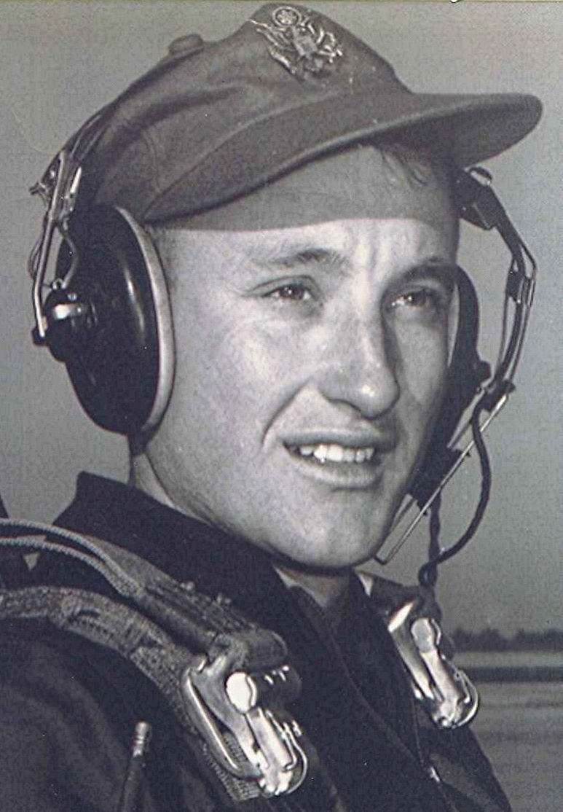
Old Ghosts Ride in the Night
November 1988
Talk about an emotional experience. Tonight I sit at the keyboard listening to a CD that has a montage of Gaither’s songs and reading a newspaper column sent me by a member of a loosely-knit group of former air force pilots who are Vietnam veterans.
I mentioned sometime back that until September, when it came to Clarksville, I had never been to the Vietnam Memorial or the replica of it that travels around the country with the names of the more than 58,000 who died over there. Tonight, I received via the Internet a Wall Street Journal column written by a former fighter pilot who has also written a book about his experiences in Vietnam.
In a way which most of us could never hope to, he has spoken for the rest of us—of the depth of feelings we have about having been there and more specifically, some of the things that ran through our minds the first time we visited the Wall.
Still the Noblest Calling
By J.D. Wetterling

[Editor’s note: The following is written by JD Wetterling.]
I visited with three old friends recently at a park near my town. It seemed like only yesterday that we were all together, but actually it had been 28 years. There was a crowd at the park that day, and it took us a while to connect, but with the aid of a computer we made it. I found Lance at panel 54W, line 037, Lynn over at panel 51W, line 032, and Vince down at panel 27W, line 103.
In 1968 we were gung-ho young fighter pilots in Vietnam, the cream of the crop of the U.S. Air Force pilot training system, and now their names are on that 250-foot-long, half-size model of Washington's Vietnam War Memorial that moves around the country. I had intentionally avoided visiting the wall when it came to town in years past because I did not trust myself to keep my composure. But after nearly three decades it was time to try for some closure on this issue. I told my wife that I preferred to go alone, if that was all right. Truth be known, I nearly backed out at that.
Dancing the Wild Blue. Standing in front of that somber wall, I tried to keep it light, reminiscing about how things were back then. We used to joke about our passionate love affair with an inanimate flying object.
We flew F-100s and we marveled at the thought that we actually got paid to do it. We were not draftees but college graduates in Vietnam by choice, opting for the cramped confines of a jet fighter cockpit over the comfort of corporate America. In all my life I've not been so passionate about any other work. If that sounds like an exaggeration, then you've never danced the wild blue with a supersonic angel.
I vividly remember the Sunday afternoon, in the summer of '68, when we flew out of Travis Air Force Base, California, on a troop transport headed for Vietnam. Lynn, Lance and I crowded around the same porthole and watched the Golden Gate Bridge disappear below broken clouds. We had gone through fighter pilot school together and had done some serious bonding. In an exceedingly rare moment of youthful fighter pilot humility, I wondered if I would live to see that bridge again. For reasons I still don't understand, I was the only one of the three of us who did.
Once in Vietnam, we passed the long, lonely off-duty hours at Dusty's Pub, a lounge that we lieutenants built on the beach of the South China Sea at Tuy Hoa Airbase.
The roof at Dusty's doubled as a sun deck and the walls were nonexistent. The complaint heard most often around the bar, in the standard gallows humor of a combat squadron, was, It's a lousy war, but it's the only one we have. (I've cleaned up the language a bit.) We sang mostly raunchy songs that never seemed to end. Someone was always writing new verses and, as an antidote to loneliness, fear in the night and the sadness over dead friends, we often drank too much.
Vince joined us at Dusty's Pub halfway through my tour of duty, and since he was a like-minded country kid from Montana, we hit it off. He had a wide grin, slightly stooped shoulders and his own way of walking he just threw his feet out and stepped on them. But what he lacked in military bearing he made up for with the heart of a tiger. He often flew as my wingman, and we volunteered for the night missions on the Ho Chi Minh Trail. One starless night, the longest, saddest night of my life, we got into a nasty gun duel with some antiaircraft artillery batteries. I watched Vince die in a mushroom-shaped fireball that for a moment turned night into day.
Lance, a New York boy who took unmerciful grief from us because he talked like a New Yawker, crashed into the side of a mountain in the central Vietnamese highlands while attacking a target. Lynn, a happy-go-lucky jock from Pennsylvania's Slippery Rock College with a hound named John the Basset, returned to his base on a stormy night in July after weather aborted his mission. Two miles of wet runway weren't enough to stop an F-100 landing at 160 knots with all its bombs still on board. He ran off the end, flipped over, and slid through the minefield at the perimeter fence, setting off a gruesome sound and light show.
At the wall, I told the guys only about the good parts of the last 28 years. Lacy, one of our associates from Dusty's Pub, became an astronaut, and a few summers ago I watched from my backyard, near Tampa, as he blasted off. His voice over the radio from space was at least an octave lower than it was the day I heard him radio for help while swinging from his parachute hung in a tree in Laos.
Another Dusty's patron, Rick, is now a two-star general, and I reminded them what we used to say about the military promotion system. It's like a septic tank, only the really big chunks float to the top. I didn't tell them about how ostracized Vietnam vets still are, that during that same week, one of the nation's leading newspapers had run an article that implied we Vietnam vets were, to quote one syndicated columnist, "either suckers or psychos, victims or monsters". I didn't tell them that the secretary of defense they fought for back then has now declared that he was not a believer in the cause for which he assigned them all to their destiny. I didn't tell them that a draft-age kid from Arkansas, who hid out in England to dodge his duty while they were fighting and dying is now the commander-in-chief. And I didn't tell them we lost that lousy war. I gave them the same story I've used since the Nixon administration: "We were winning when I left".
I relived that final day as I stared at the black onyx wall. The dawn came up like thunder after 268 combat missions in 360 days in the valley of the shadow. The ground trembled as 33 F-100s roared off the runway, across the beach and out over the South China Sea, climbing into the rising sun. On the eastern horizon, a line of towering deep-purple clouds stood shoulder-to-shoulder before a brilliant orange sky that slowly turned powder blue from the top down. From somewhere on that stage, above the whine of spinning turbine blades, I could hear a choir singing Handel's Hallelujah Chorus in fortissimo: The Lord God omnipotent reigneth, and He was bringing me home, while Lance and Lynn and Vince will remain as part of the dust of Southeast Asia until the end of time.
I was not the only one talking to the wall through tears. A leather-vested, bare-chested biker two panels to my left was in even worse shape. I backed about 25 yards away from the wall and sat down on the grass under a clear blue sky and midday sun that perfectly matched the tropical weather of the war zone. The wall, with all 58,200 names, consumed my field of vision. I tried to wrap my mind around the megatonnage of violence, carnage and ruined lives that it represented. Then I thought of how Vietnam was only one small war in the history of the human race. I was overwhelmed with a sense of mankind's wickedness.
My heart felt like wax in the blazing sun and I was on the verge of becoming a spectacle in the park. I arose and walked back up to the wall to say goodbye and ran my fingers over the engraved names Lance and Lynn and Vince as if I could communicate with them in some kind of spiritual Braille. I wanted them to know that God, duty, honor and country will always remain the noblest calling. Revisionist history from elite draft dodgers trying to justify and rationalize their own actions will never change that.
I have been a productive member of society since the day I left Vietnam. I am proud of what I did there, and I am especially proud of my friends - heroes who voluntarily, enthusiastically gave their all. They demonstrated no greater love to a nation whose highbrow opinion makers are still trying to disavow them. May their names, indelibly engraved on that memorial wall, likewise be found in the Book of Life.
(Just released is Mr. Wetterling's novel based on his service in Vietnam, entitled "Son of Thunder", by Rivilo Books. It is available through Barnes & Noble.)

I can only hope that the above, parts of which are beautifully poetic, affected you half as much as it did me.…
God’s Blessings and Peace
Postscript
[Editor’s note: The following is an email from Richard Boyd Dodson to JD Wetterling, plus an email response from JD to Boyd.]
Email by Richard Boyd Dodson:
Although not a fighter pilot, I shared a year with the F-4 guys at Phu Cat (1970-71) while doing short-field bush pilot work in I Corps with the Caribou Squadron there. Have always had the greatest respect for the single engine guys. Although I finished single engine training at Bryan AFB, Texas, I opted for AOTP (navigator training for pilots) at James Connally AFB, Waco, Texas, and then B-47's, B-52's, C-141's, and an assortment of others including the year in Caribous in Vietnam.
I really enjoyed the book, as many of the places of which you wrote are familiar. It brought back great memories as well as providing an insight into how it really was in the cockpit of the F-100 on those black nights. It is written in such a way that those who aren't pilots will be absorbed, but it is especially meaningful to those of us who have "slipped the surly bonds."
Although you didn't say it explicitly, I sensed that you had an epiphany while there. Seeing the link to the Christian Fighter Pilots organization reinforces that belief.
The thing that led to my buying your book was your article in the Wall Street Journal, relating your visit to the Moving Wall. I was deeply moved and grateful to see many of the emotions that I share expressed in such an eloquent way. Thanks for that; you did a great service for the rest of us whose ability to express those feelings are limited.
My nephew, Freddie D. Dodson, was killed near Pleiku when his army helicopter was shot down--early on, when practically no one had heard of Vietnam. His name is on the middle (first?) panel, about a third of the way down from the top.
Warmest Regards and God's Blessings
Richard Boyd Dodson
Major, USAF Retired
Dyer, Arkansas
Email response by JD Wetterling:
Dear Richard,
I can't imagine every getting tired of reading mail like yours. Thank you very much for the kind words re SOT. The epiphany in my life came as a teenager and Vietnam forever cemented my faith in a God of Providence. Today I'm a stockbroker with Morgan Stanley Dean Witter but my passion is writing, and I hope and pray that one day soon I will be able to write all day every day for the rest of my days.
So please rave about my book but don't loan it to too may people. I cannot change careers on borrowed books.
I'm a Presbyterian elder as well, and our church is between preachers so I had the great blessing of preaching Christmas Eve.
Grace and peace to you and your family this Christmas season,
JD

