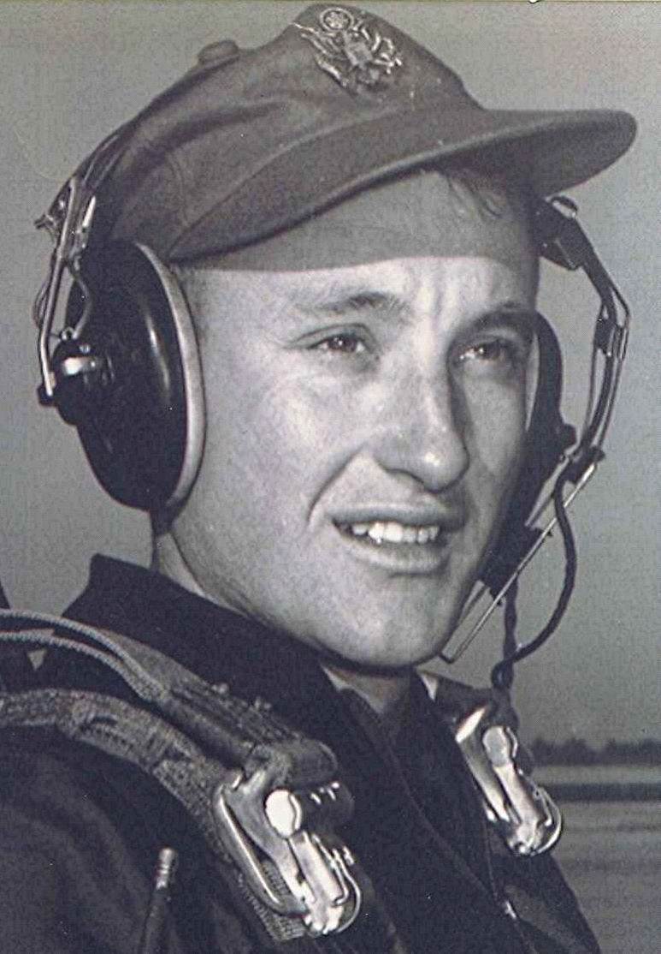
On Contemplating
November 1988
One of my favorite recordings is from a CD titled “Those Wonderful Years.” The pop title of this song is “To Love Again” and is taken from the motion picture, “The Eddie Duchin Story.” I remember when Eddie Duchin played the piano during broadcasts on the radio back in the forties. The song “To Love Again” is a variation of Chopin’s E Flat Nocturne and is performed by Carmen Cavallaro’s Orchestra. Talk about a name with a lyrical sound; Carmen Cavallaro sounds as if it should be put to music

While on the subject of music, one of the most impressive groups of people I have ever seen is that of some old gospel singers. I first heard about the Gaithers, Bill and Gloria, about four or five years ago when we bought some of their recordings of various quartets and gospel groups who came together at the Gaither place in Indiana for a session of impromptu singing. Those first recording sessions were so successful that they were followed by other, more elaborate gatherings at different places around the country. The Gaithers have written over a thousand songs, mostly gospel .

A lot of the earlier tapes are of the older generation of singers, most of whom are in their sixties and seventies. I have been struck by the mature quality of vocal chords that must have sung a million songs during their lifetime. The second impressive thing is the look of peace upon the faces of folks who are literally knocking at Heaven’s door at this point in their life. Calm, unlined visages reveal a lifetime of service to God through their songs.

As a member of humanity’s throng of off-key, tone deaf folks, it has always been a source of awe to witness someone who has tapped into that mysterious realm of music and who has a voice with which to demonstrate its wonders. I envy those who have a natural antenna with which to receive impulses from that other world, a talent denied the majority of the rest of us.

