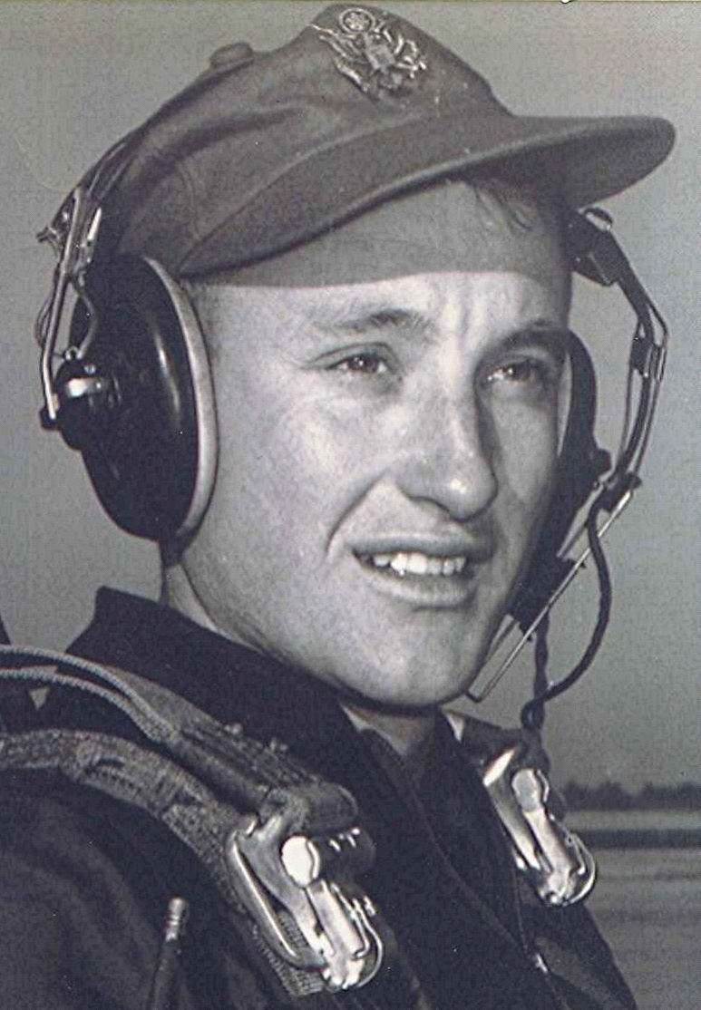
Thoughts emanating from a fevered mind
And I could write half a page of memories of the times when the county nurse came to the Methodist Church at Holly Springs, [Arkansas,] and administered typhoid shots. Series of three, a week apart. It was in the hottest part of the summer. Needle as big as that on a basketball pump. Big enough to use on a horse or cow. Lord, how Nurse X’s shots hurt and how I dreaded them. I can still smell the fumes of hot alcohol in a metal dish where the needles were sterilized.

The county nurse was a very large woman with a bobbed-off-short haircut. She struck terror into the heart of this scared kid. Given the pain she inflicted, that terror was pretty much justified. I would rather had a case of typhoid than to face that needle three times; not to mention the subsequent sore arm and the fever that followed each episode.

"Truth is a shining goddess, always veiled, always distant, never wholly approachable, but worthy of all the devotion of which the human spirit is capable."
Bertrand Russell
University Education
.

