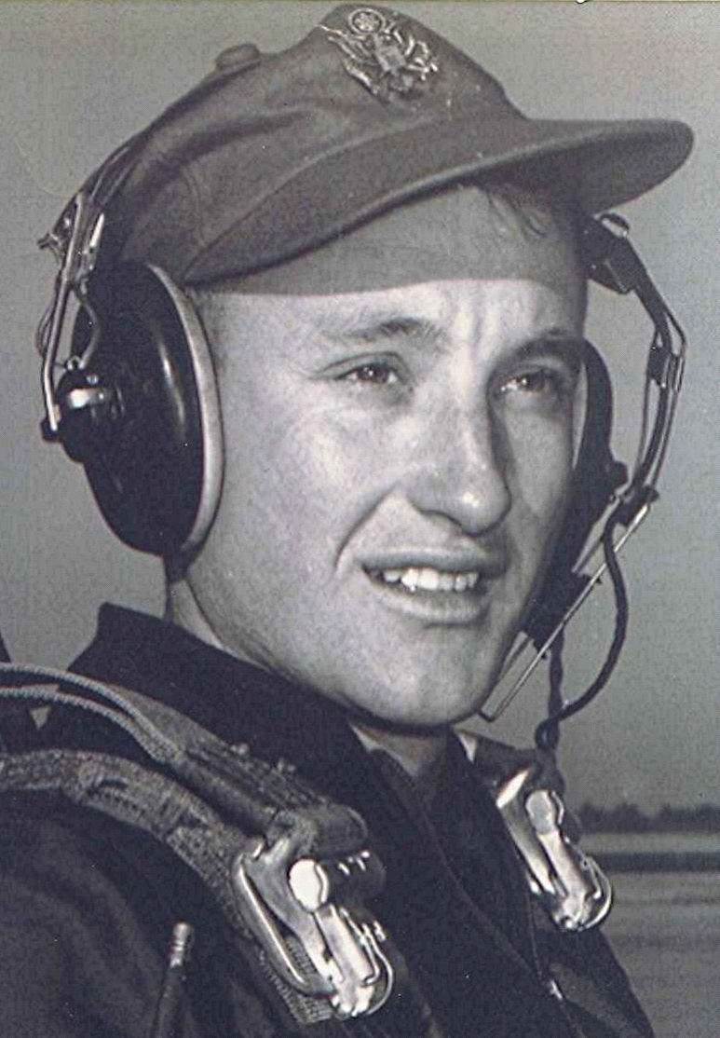
The Long and Winding Road
A couple of years ago we took a side trip while on an overnighter in Arkadelphia. To Sparkman, Holly Springs, Princeton, Manning and Shady Grove; some of which it had been fifty years since I was last there. It is next to impossible to express the feelings one experiences when returning to these places that are so laden with memories, yet in many ways so different from that I knew back when. The passage of fifty years has erased or altered many of the objects of my teenage recollections.
Thinking about all that and what it means as we travel down the trail toward our ultimate destiny brings more questions than answers. I keep remembering what it was like when we were kids and our parents were closer to the ages we are now. Back then a teenager’s world and the time available in which to experience it seemed to stretch forth in an unending stream. But now I know that was only an illusion. It has always been a fact that the long and winding road ended some- where out there beyond the green vistas and purple hills that obscured that last mile.
[Editor’s note: The towns mentioned above are in Arkansas, USA, the area in which Boyd grew up and attended school.]
.

