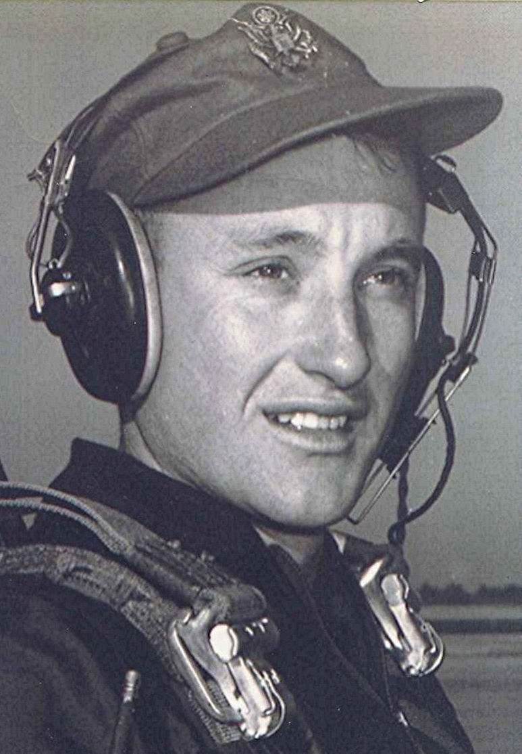
Ode to the hunters from the Class of 1951
He arises early when the frost is on the punkin' . He summons his faithful hound and together they stride through the sedge and brambles in quest of the elusive game.

He returns in the evening, heart full, game bag empty, but hope springing eternal at thoughts of the next time when he will again follow his faithful companion's sniffings in pursuit of Bambi and Peter Cottontail.

For he knows that soon the eye will grow dim and the step weakened and wobbly. When he will be unable to align gun and aim and trigger; becoming a hazard to his dog, companions-himself. He will watch as others, younger and keener of eye load the camper and call the dogs and head out to the big woods.

Left by the fireside, he will sit and contemplate the big ones that stride through the brush, their racks held high, their vision clearer than the one who stares dimly at the fire, dreaming.

I.M. Squatley, November 1986
.

